# CMP020X305S: BSc Cyber Security

**Portfolio Lab 04 (of 06): Vulnerability Scanning and Brute Force Password Attacks with WPScan**

| **Set Date:** | **10th March 2023** |
| --- | --- |
| **Requirement A** | Vulnerability Scanning and a Brute Force Password Attack with WPScan |
| **Milestone Deadline:** | 24th March 2023 |
| **Coursework Deadline:** | 28th March 2023 by 16:00 hours |
| **Submission Format:** | Upload a single document to Moodle |
| **Feedback and Marks:** | Via Moodle |
| **Marking Scale (Lab):** | Maximum 10.0 marks for completion of portfolio requirements |
| **Marking Scale (Wow Factor):** | Maximum 6.6 marks for Wow Factor |
| **Learning Outcome LO2:** | Investigate measures that can be taken by both individuals and organizations including governments to prevent or mitigate the undesirable effects of computer crimes and identity theft. |
| **Learning Outcome LO4:** | Evaluate risks to privacy and anonymity in commonly used applications. |

**IMPORTANT: This is a living document and will be subject to changes and updates during the life cycle of the lab portfolio. Therefore, it is imperative that you check this document regularly!!**

**ACADEMIC MISCONDUCT**

Your submission for this coursework will be scrutinised for plagiarism, collusion, and other forms of academic misconduct. Please ensure that the work that you submit is your own, and that you have cited and referenced appropriately, to avoid having to attend an academic misconduct hearing.

**About this portfolio lab**

This portfolio lab is problem centred. Therefore, you will need to research and take responsibility for solving any technical challenges that you encounter. You are encouraged to work collaboratively with other students in your cohort. However, the work that you submit must be your own and any sources of assistance etc, must be acknowledged through referencing or where appropriate, code comments.

For this portfolio, you will:

1. research WPScan.
2. use WPScan to evaluate vulnerabilities in your WordPress virtual machine.
3. use WPScan to conduct a brute force password attack on your WordPress virtual machine.

**Resources Required for this Portfolio Lab**

This lab requires resources from Portfolio 01:

* Kali Linux
* Ubuntu Server Gateway
* Ubuntu WordPress 14.04

**Marking Criteria**

This portfolio will be marked in accordance with the following rubrics:

| **Portfolio Requirement:** Vulnerability Scanning and a Brute Force Password Attack with WPScan | **Maximum Mark** |
| --- | --- |
| Not attempted | 0 |
| Evidence of a very limited level of completion in accordance with the requirement description. | 1.0 - 2.1 |
| Evidence of a limited level of completion in accordance with the requirement description. | 2.1 – 2.5 |
| Evidence of an adequate level of completion in accordance with the requirement description. | 2.6 - 3.0 |
| Evidence of a good level of completion in accordance with the requirement description. | 3.1 - 3.5 |
| Evidence of full completion in accordance with the requirement description. | 3.6 - 5.0 |

| **Portfolio (Optional): Wow factor!!** | **Maximum Mark** |
| --- | --- |
| Not attempted | 0 |
| Evidence of a very limited attempt that is not directly relevant to the portfolio. | 1.0 - 2.6 |
| Evidence of a limited attempt that is somewhat relevant to the portfolio. | 2.7 - 3.2 |
| Evidence of an adequate attempt that is mostly relevant to the portfolio. | 3.3 - 3.9 |
| Evidence of a good attempt that is relevant to the portfolio. | 4.0 - 4.6 |
| Evidence of a very good attempt that is relevant to the portfolio. | 4.7 - 5.2 |
| Evidence of an excellent attempt that is relevant to the portfolio. | 5.3 - 6.6 |

The **maximum mark** **for completing Requirements A and B for this lab portfolio is 10**. An **additional maximum mark of 6.6** can be awarded for "**Wow Factor**" that evidences appropriate, relevant and additional learning. Typically, wow factor demonstrates a self-study contribution that extends or advances the core technical requirements of a lab portfolio.

**Late Portfolio Submissions**

For each week that a portfolio is late, two marks will be deducted from the portfolio score that is awarded at the time of assessment.

**Requirement A: Vulnerability Scanning with WPScan**

**Working with WPScan**

The diagram below describes the role of each virtual machine asset in this portfolio activity.

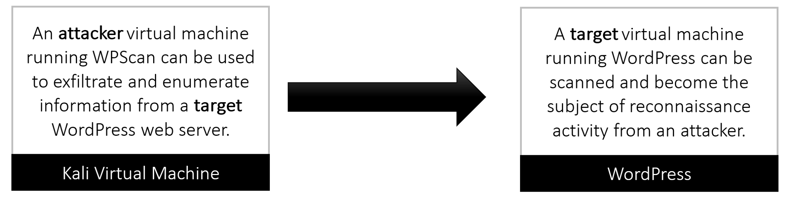

1. Get to know WPScan. Visit the following website to familiarise yourself with the basic concept of WPScan: <https://wpscan.org/>
2. Make sure that kali and wordPress can ping each other successfully.
3. Make sure that you can browse from kali, to wordPress.
4. From the Kali virtual machine open a web browser and enter the IP address of wordpress appended with /wp-admin. For example: 192.168.123.xxx/wp-admin.
5. Create a new admin user with a weak password selected form here: <https://en.wikipedia.org/wiki/List_of_the_most_common_passwords>
6. Test that new login account to ensure that it works.

**Update WPScan**

1. On your kali virtual machine, select the Kali Applications Launcher >> select 03 – Web Application Analysis select >> wpscan as indicated below.

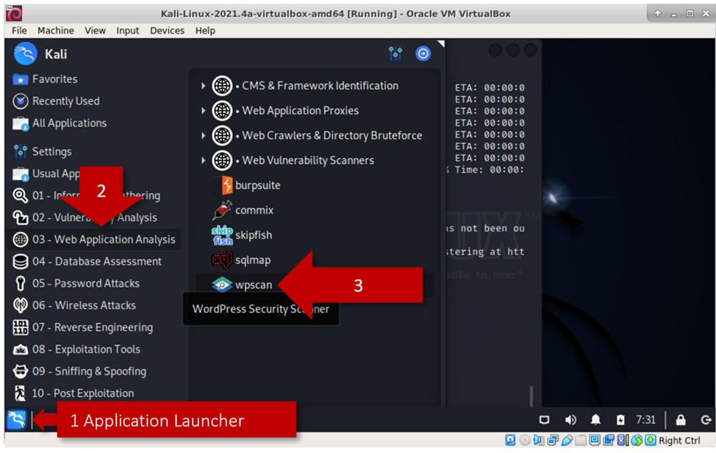

1. This will open a new terminal window. From the wpscan terminal type:

wpscan --update

The expected result should be similar to that shown below.

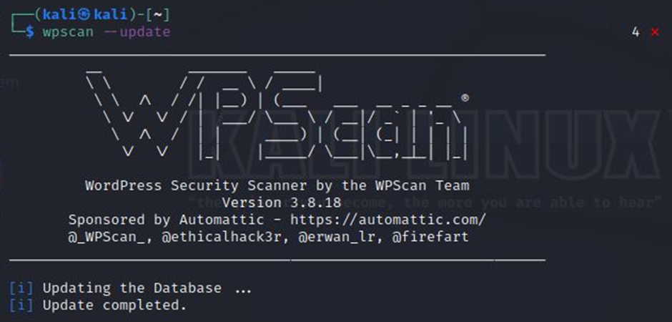

**Testing WPScan Commands**

Complete all of the following commands for wordpress. NOTE: Substitute xx for the value of your own WordPress virtual machine IP address.

**1:** Enumerate information from your WordPress website. Type:

wpscan --url 192.168.123.xx

**REPLACE THIS LINE WITH A CAPTURE OF YOUR SCREENSHOT(S) HERE!**

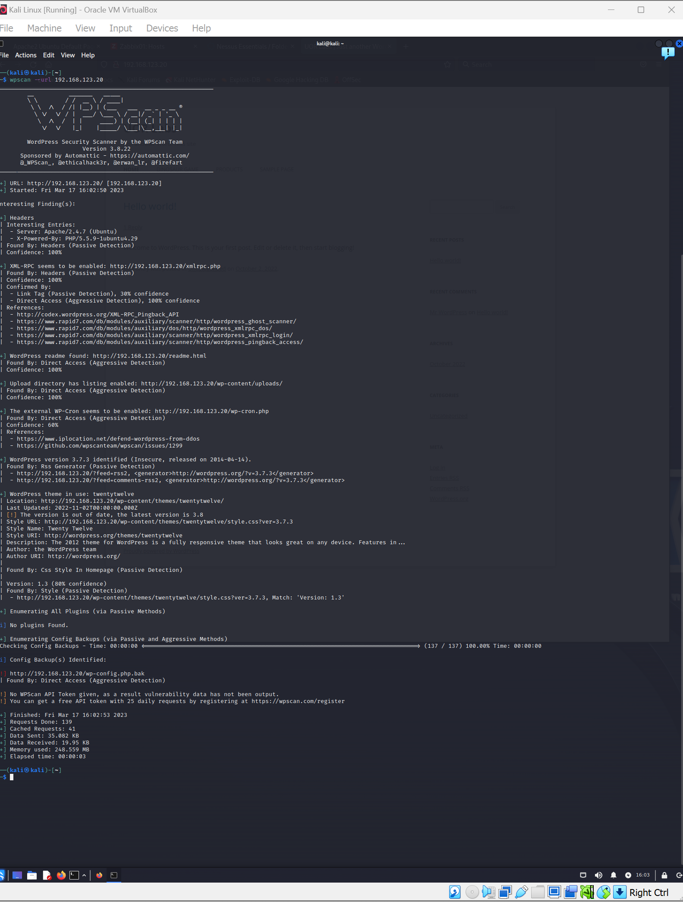

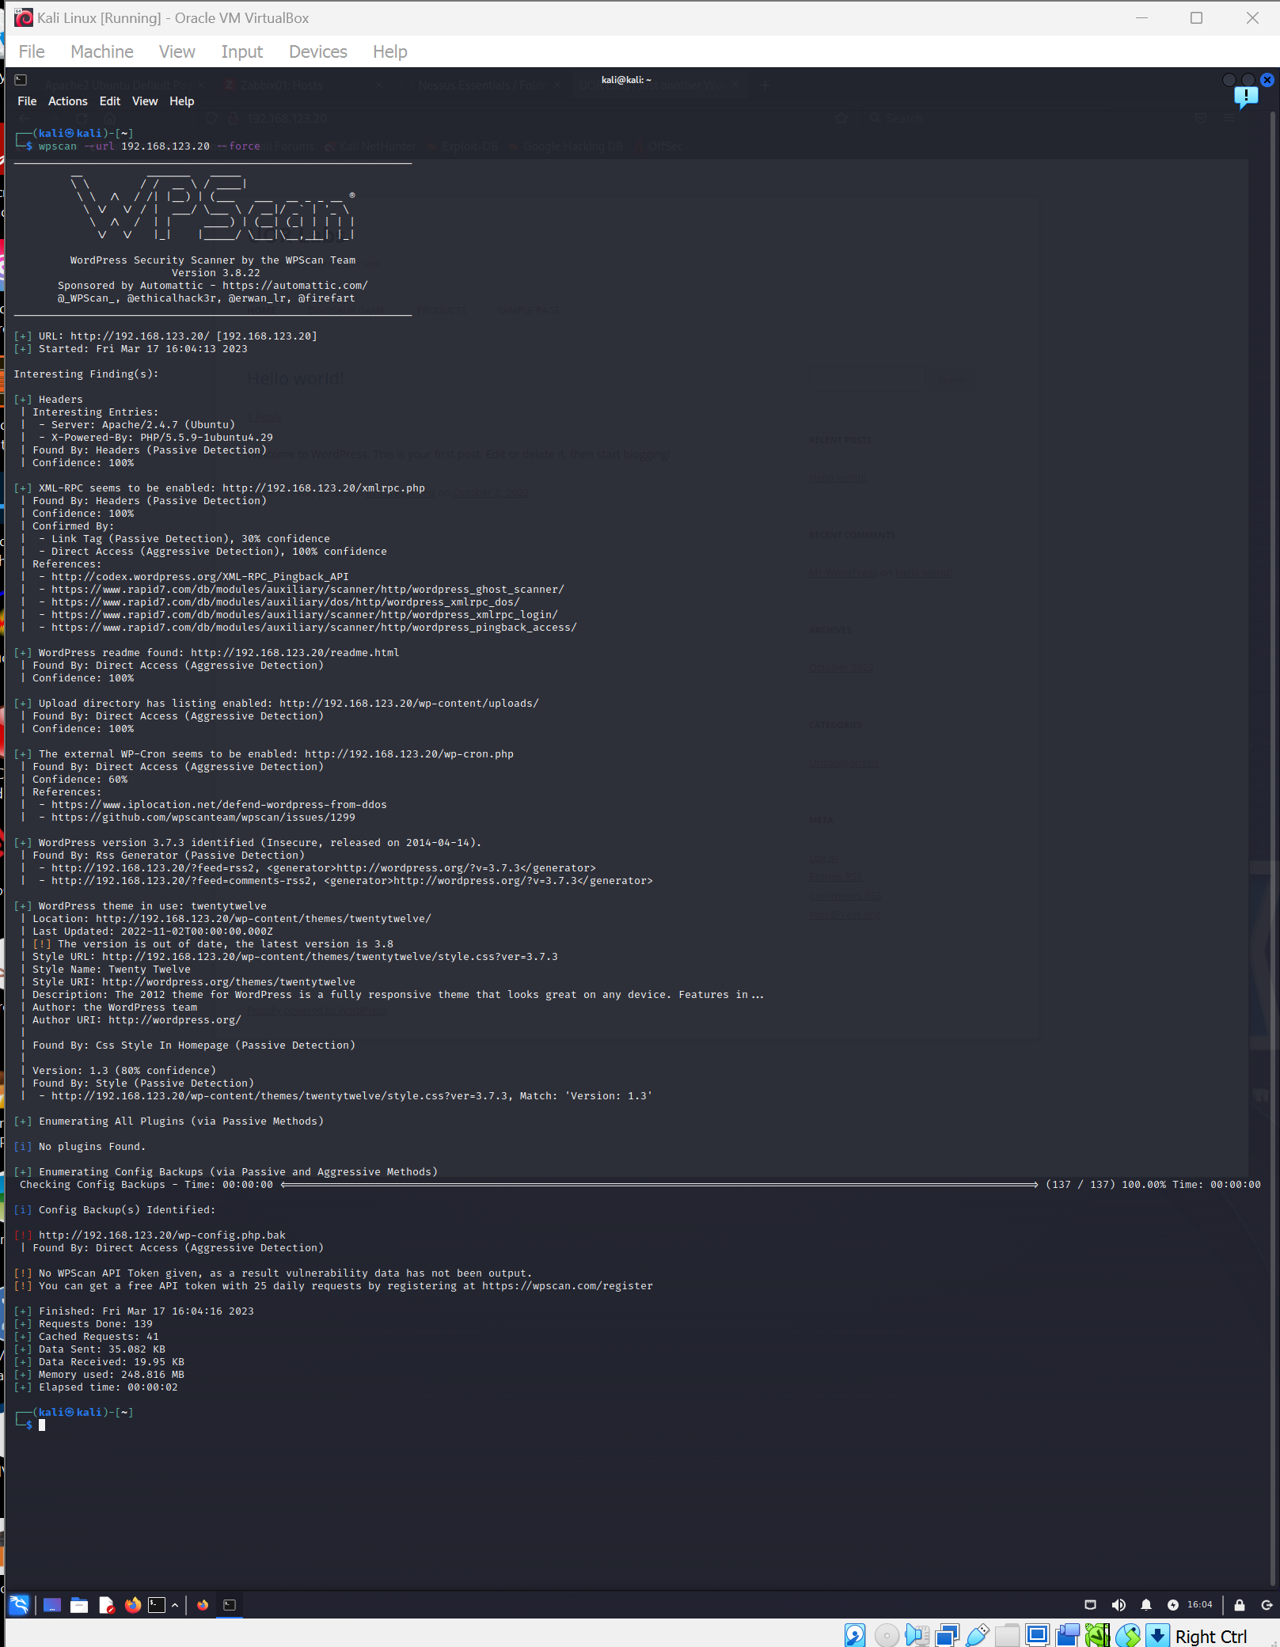

**2:** Adding the **enumerate** command adds additional scanning options. For example, to scan WordPress for **published plugins**, use the **enumerate** value in conjunction with the **p** option. Type:

wpscan --url 192.168.123.xx --enumerate p

**REPLACE THIS LINE WITH A CAPTURE OF YOUR SCREENSHOT(S) HERE!**

**Capture the command that was issued and the relevant section from the output that relates to the command.**

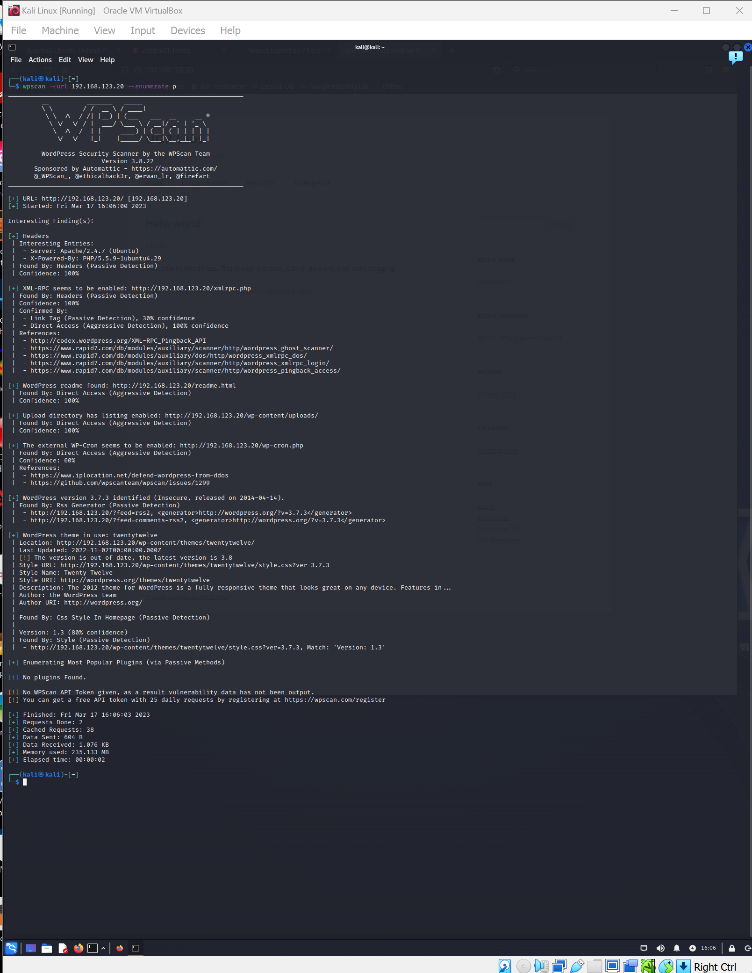

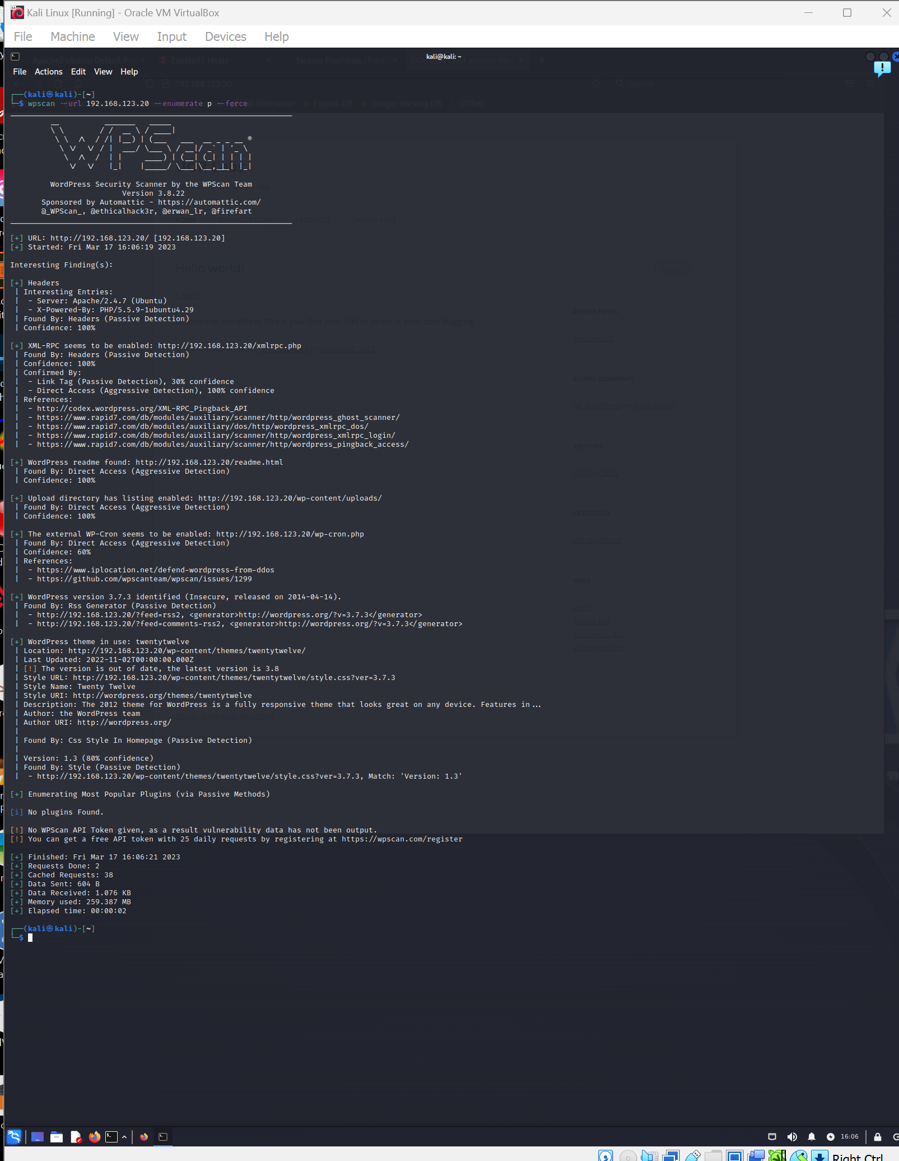

**3:** To scan WordPress for **vulnerable plugins only**, use the **enumerate** value in conjunction with the **vp** option. Type:

wpscan --url 192.168.123.xx --enumerate vp

**REPLACE THIS LINE WITH A CAPTURE OF YOUR SCREENSHOT(S) HERE!**

**Capture the command that was issued and the relevant section from the output that relates to the command.**

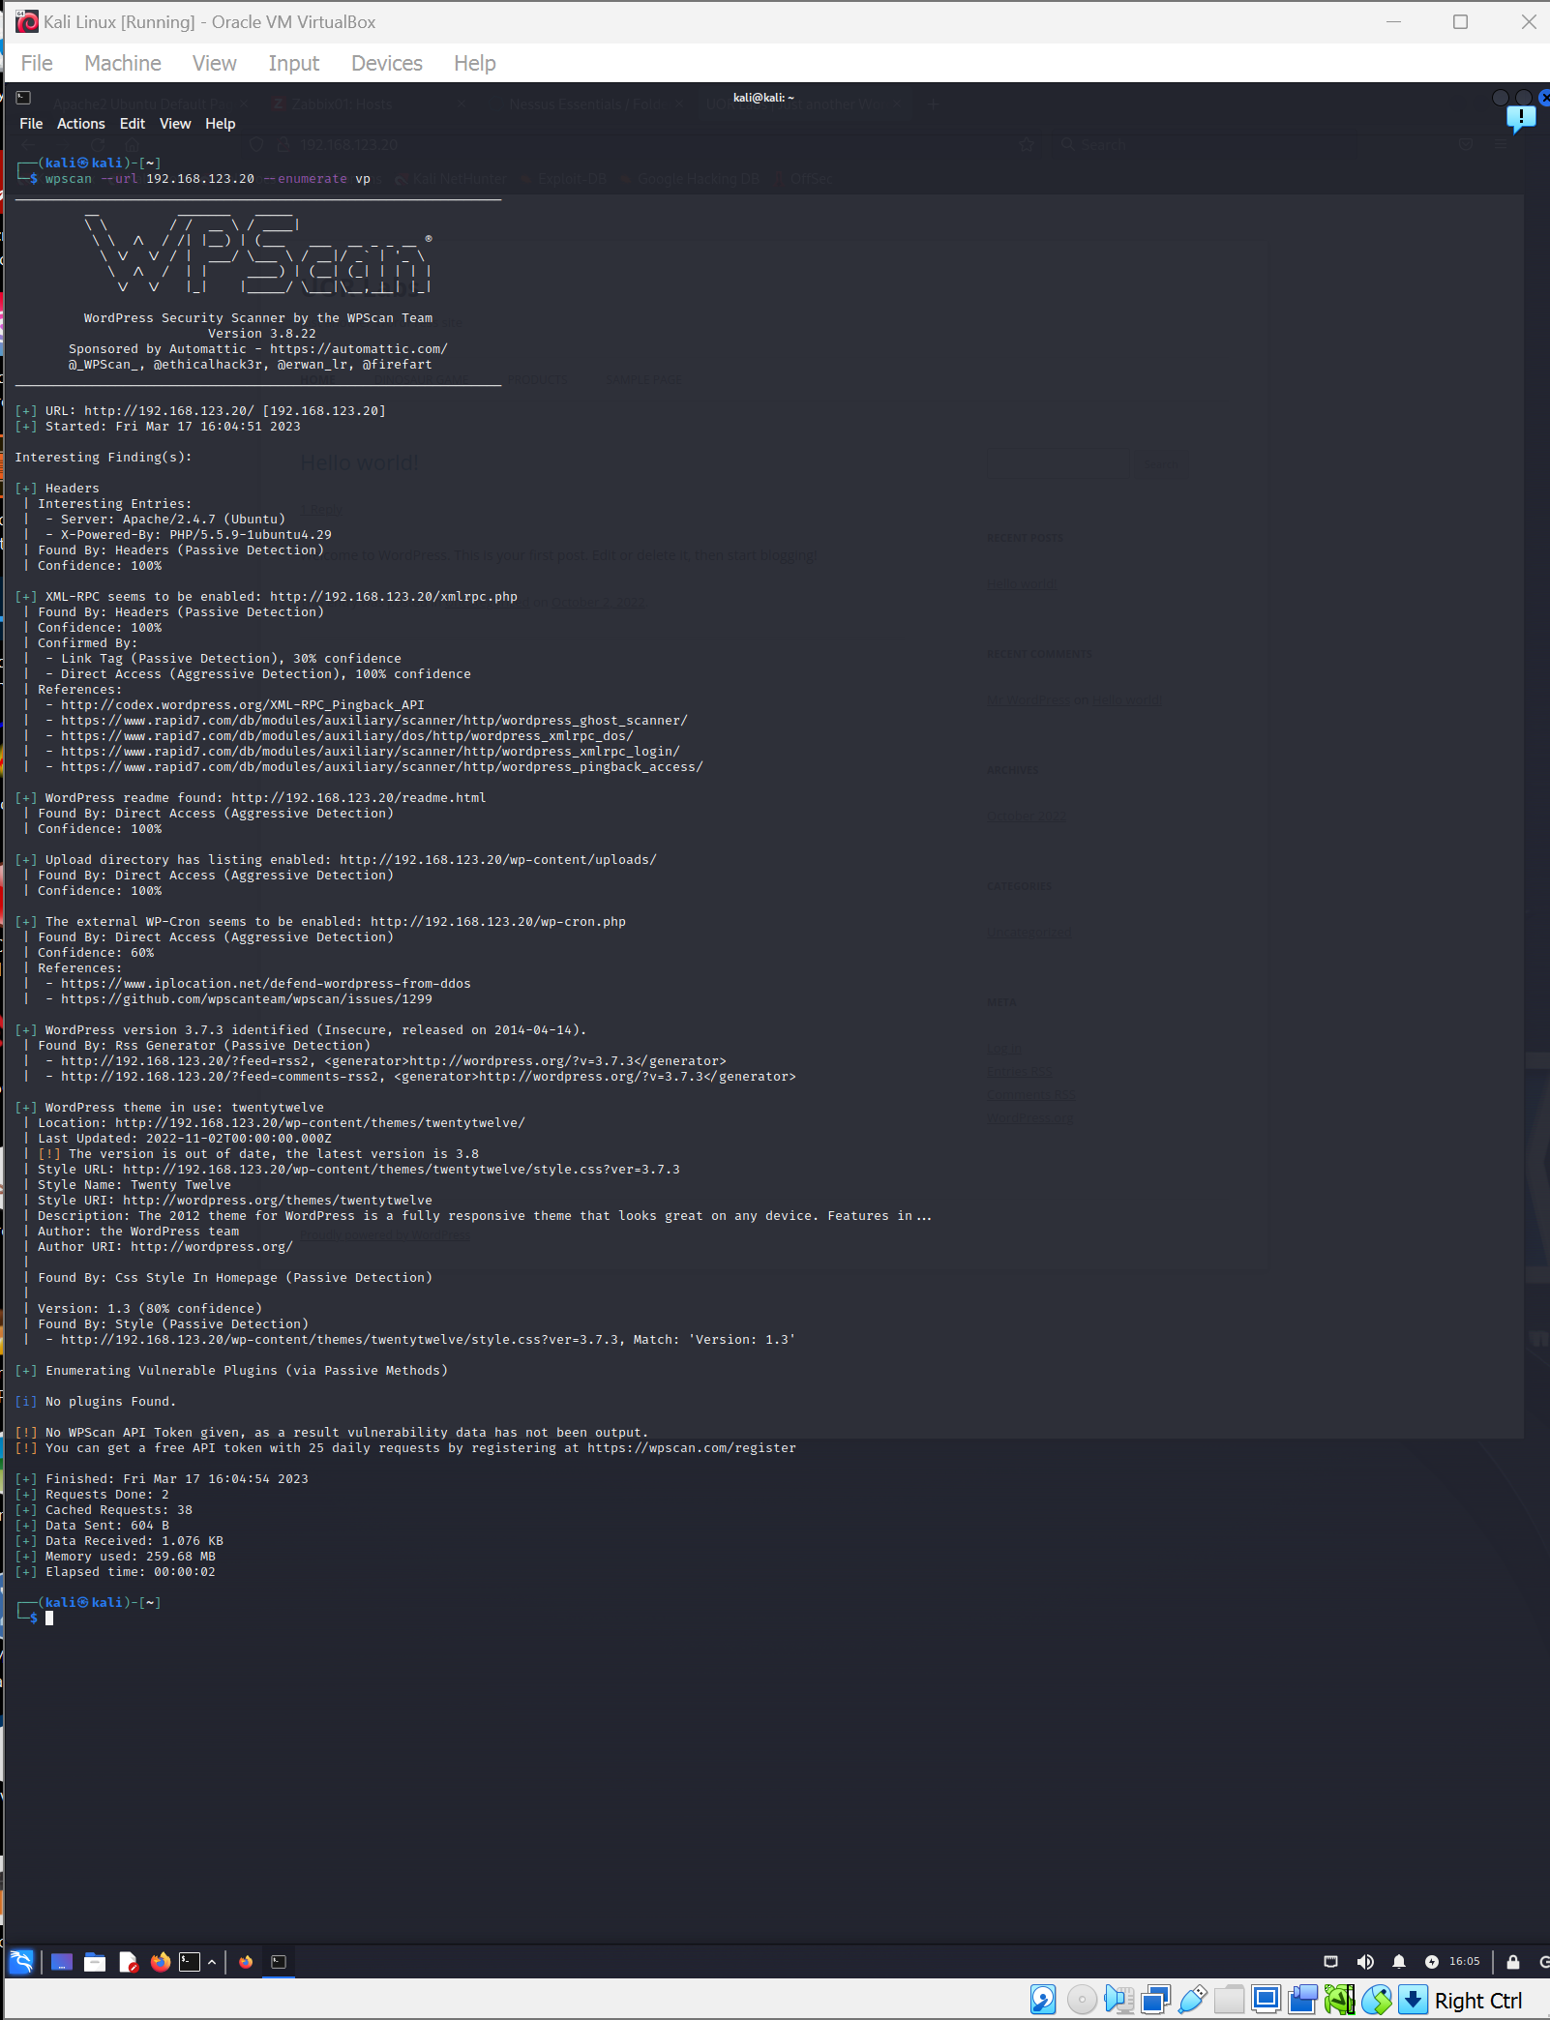

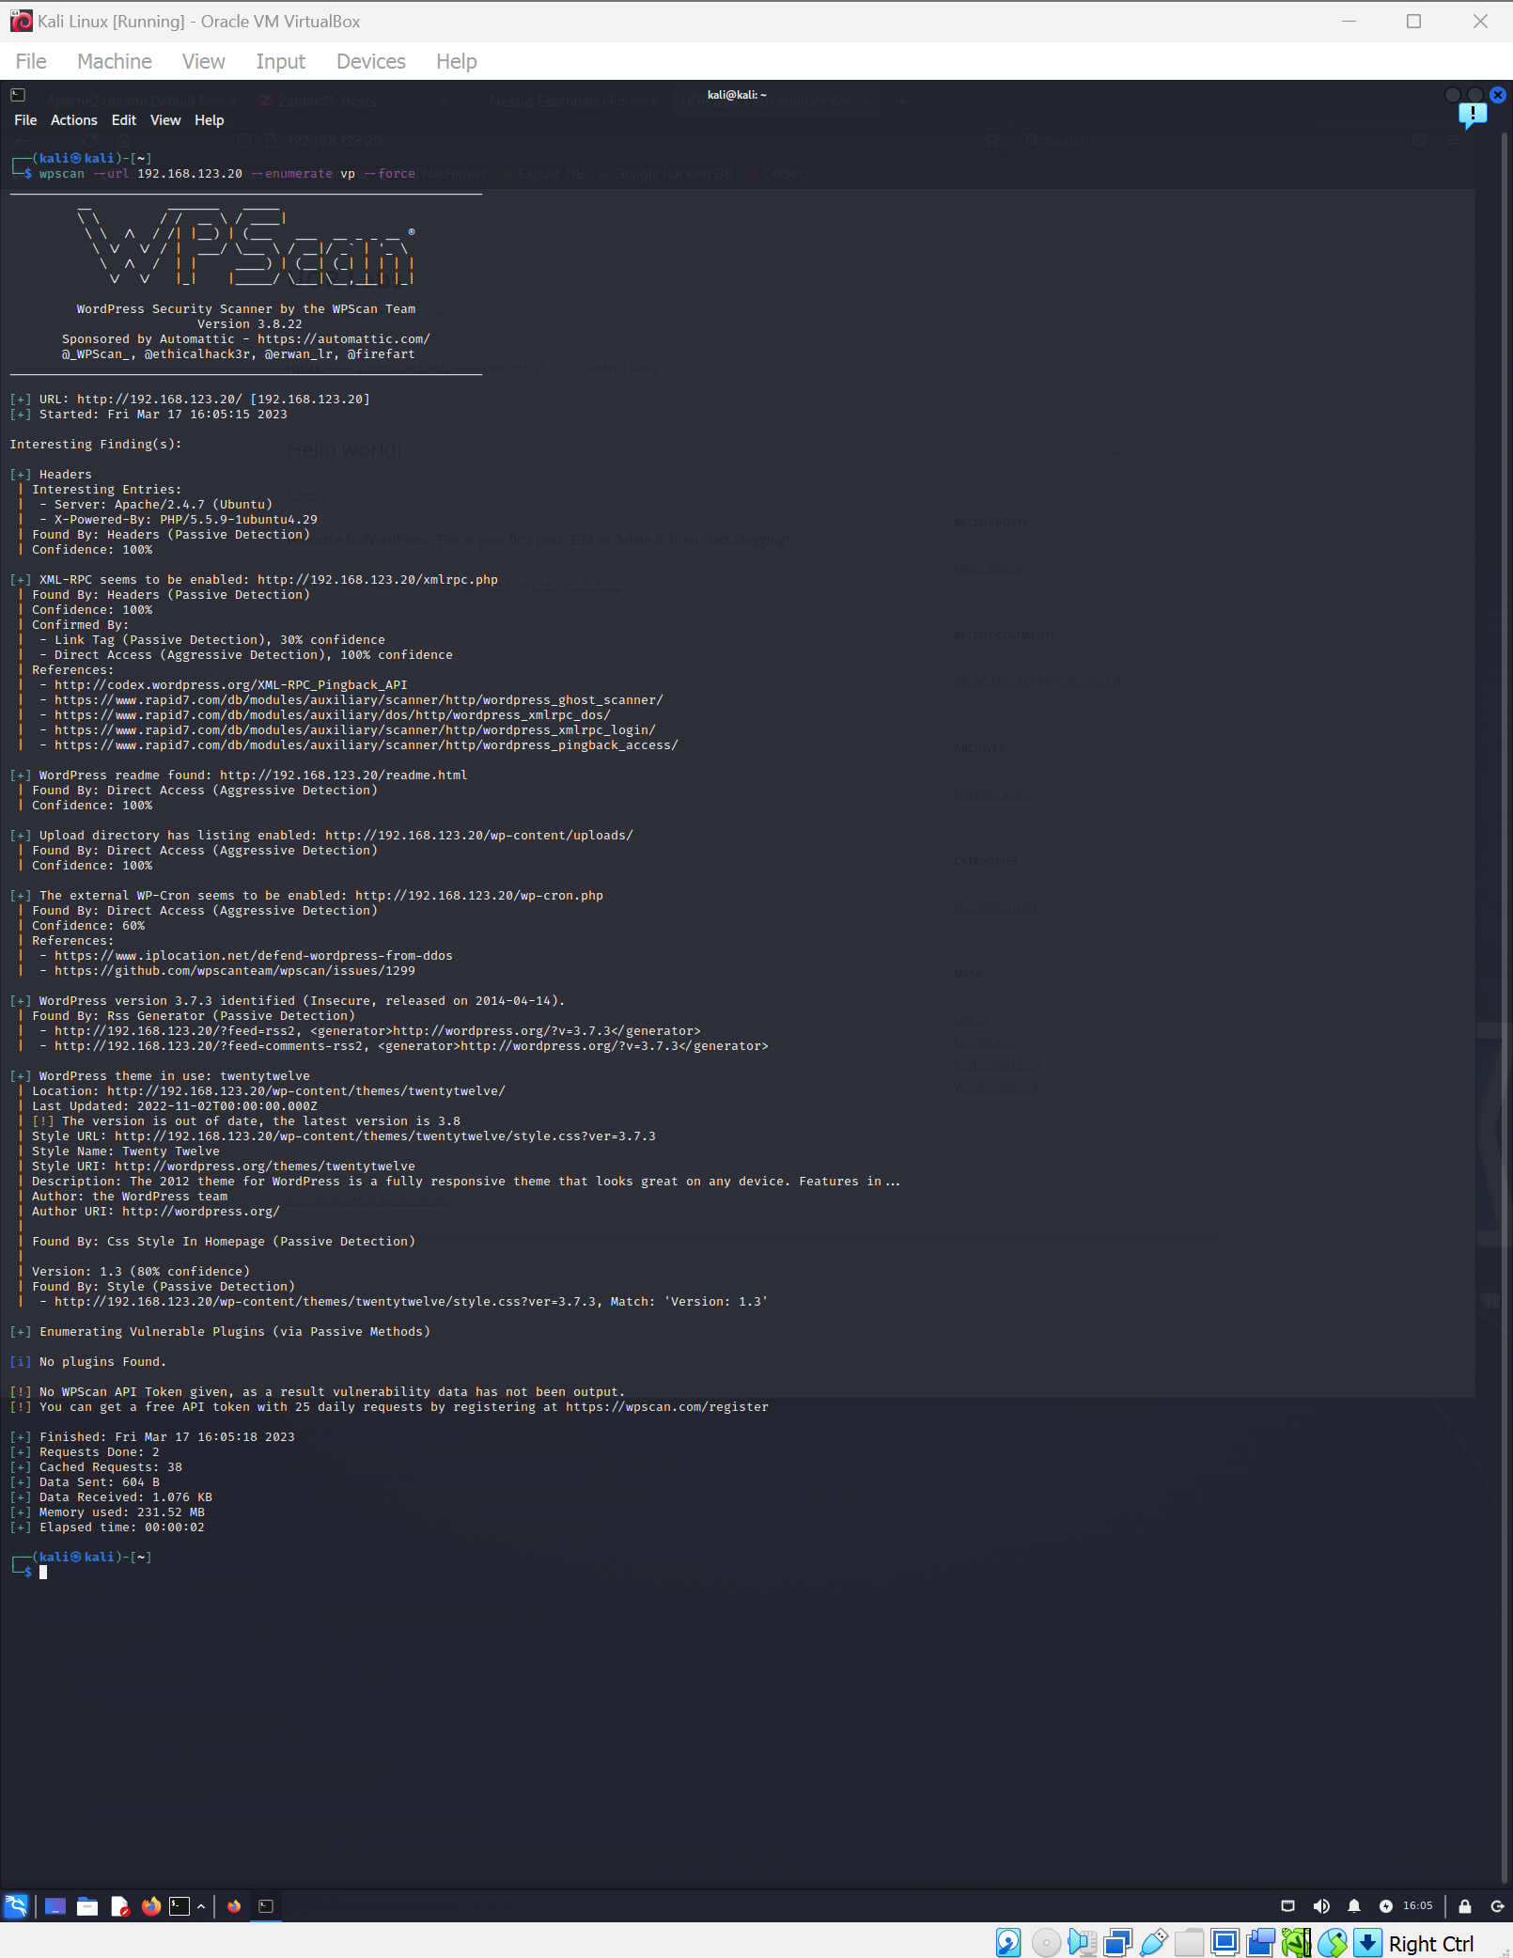

**4:** To scan WordPress for **all plugins** (published and unpublished), use the **enumerate** value in conjunction with the **ap** option. Type:

wpscan --url 192.168.123.xx --enumerate ap

**REPLACE THIS LINE WITH A CAPTURE OF YOUR SCREENSHOT(S) HERE!**

**Capture the command that was issued and the relevant section from the output that relates to the command.**

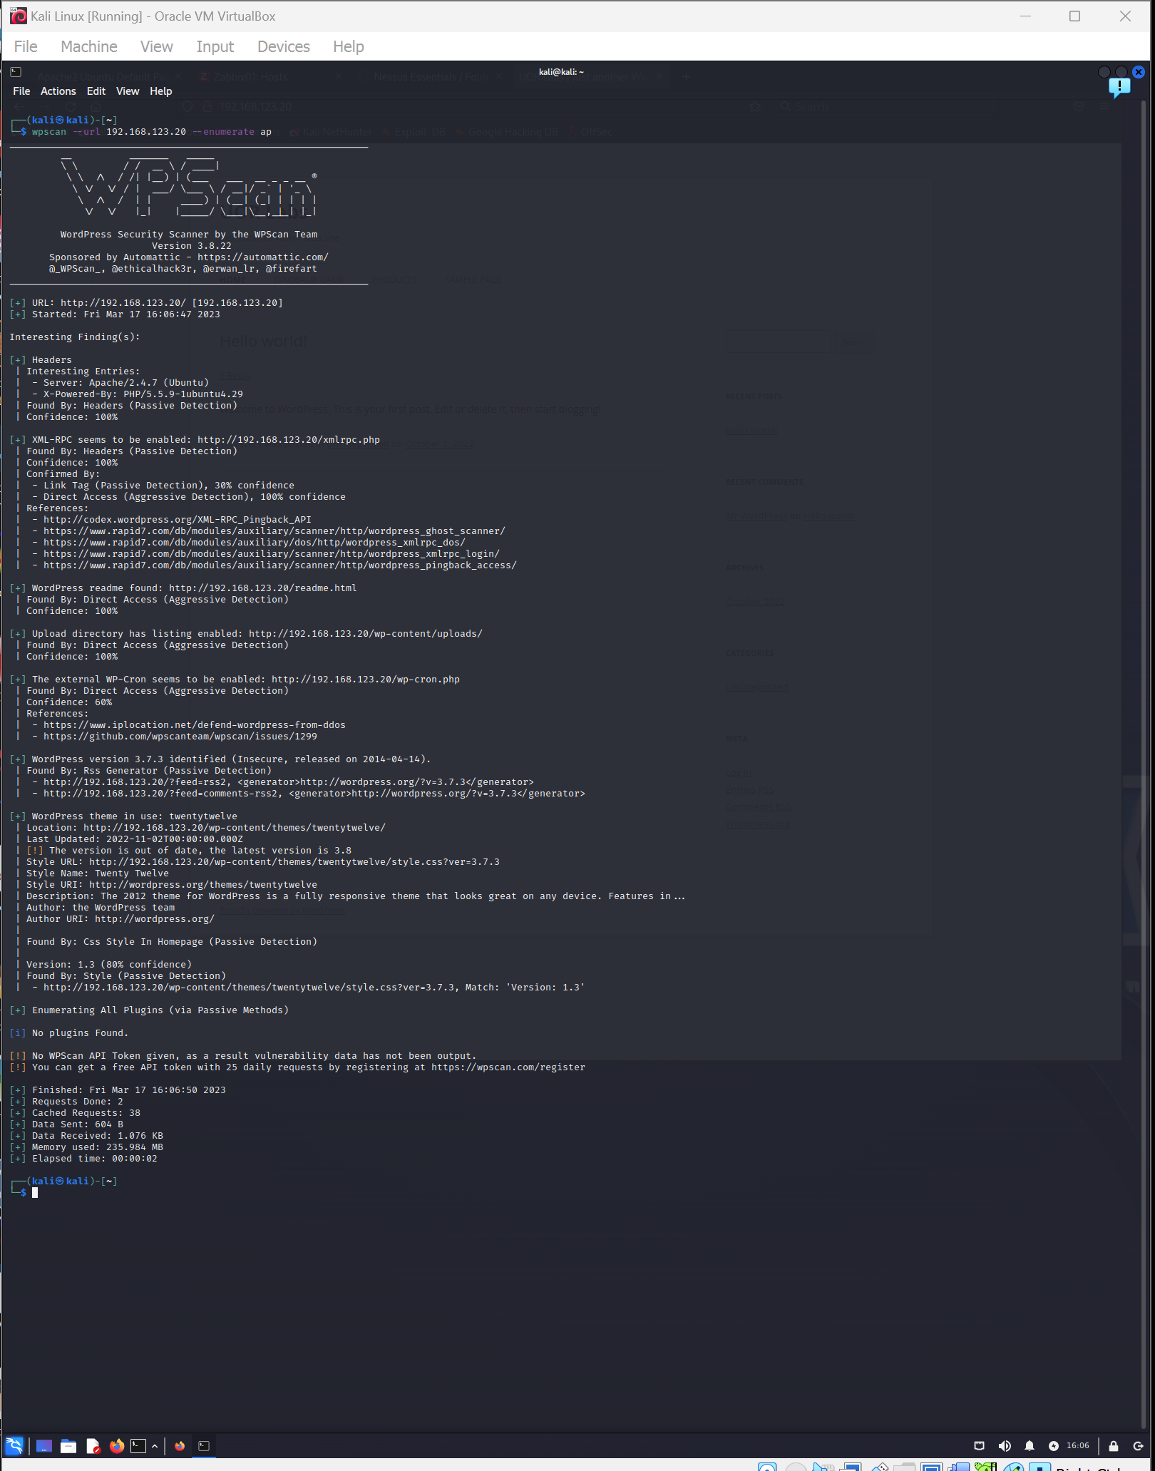

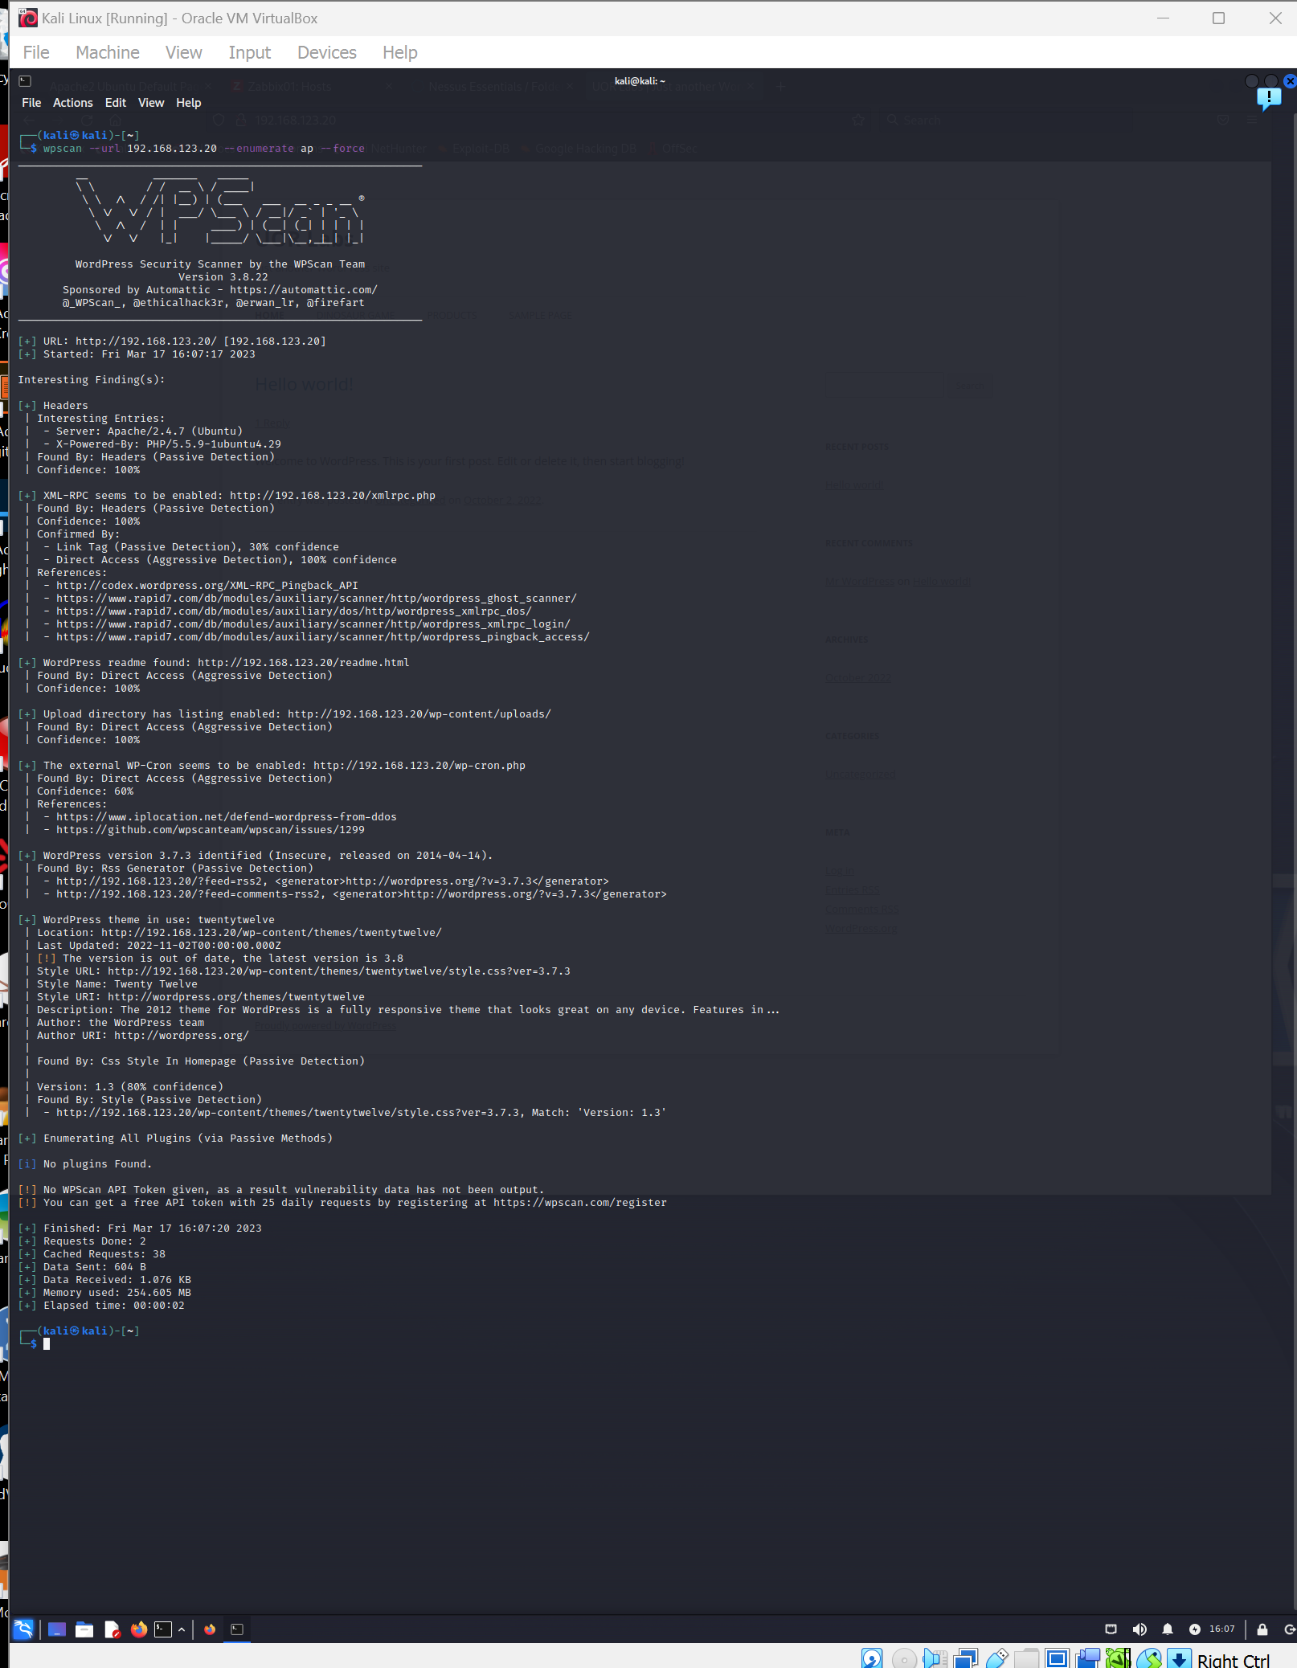

**5:** To scan WordPress for **themes**, use the **enumerate** value in conjunction with the **t** option. Type:

wpscan --url 192.168.123.xx --enumerate t

**REPLACE THIS LINE WITH A CAPTURE OF YOUR SCREENSHOT(S) HERE!**

**Capture the command that was issued and the relevant section from the output that relates to the command.**

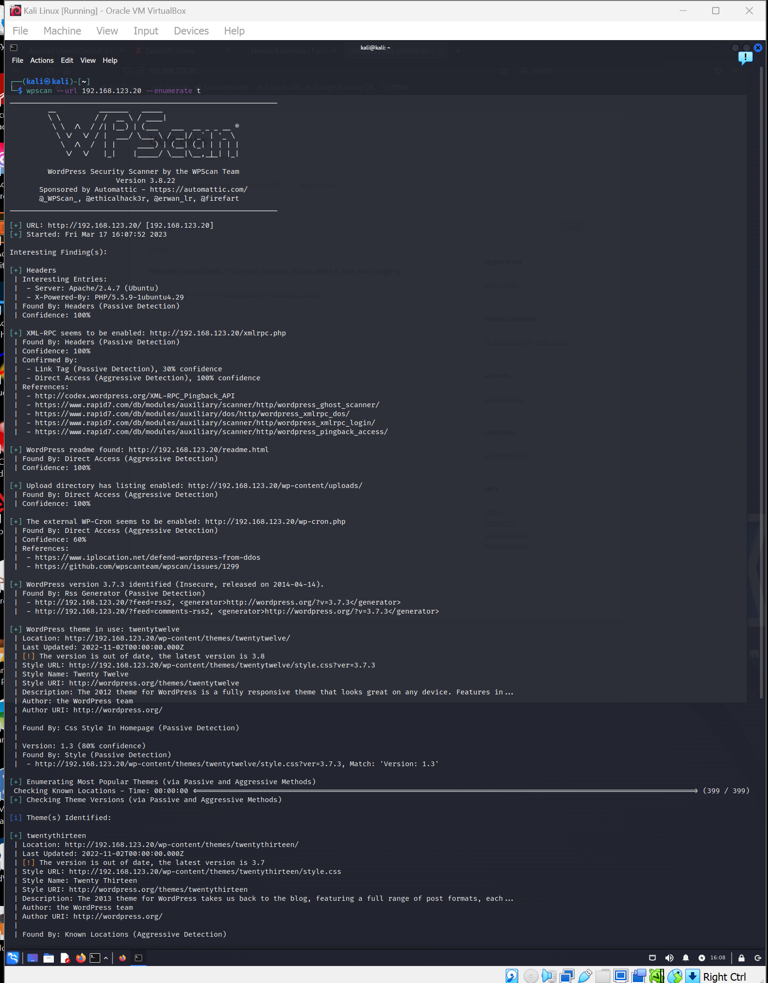

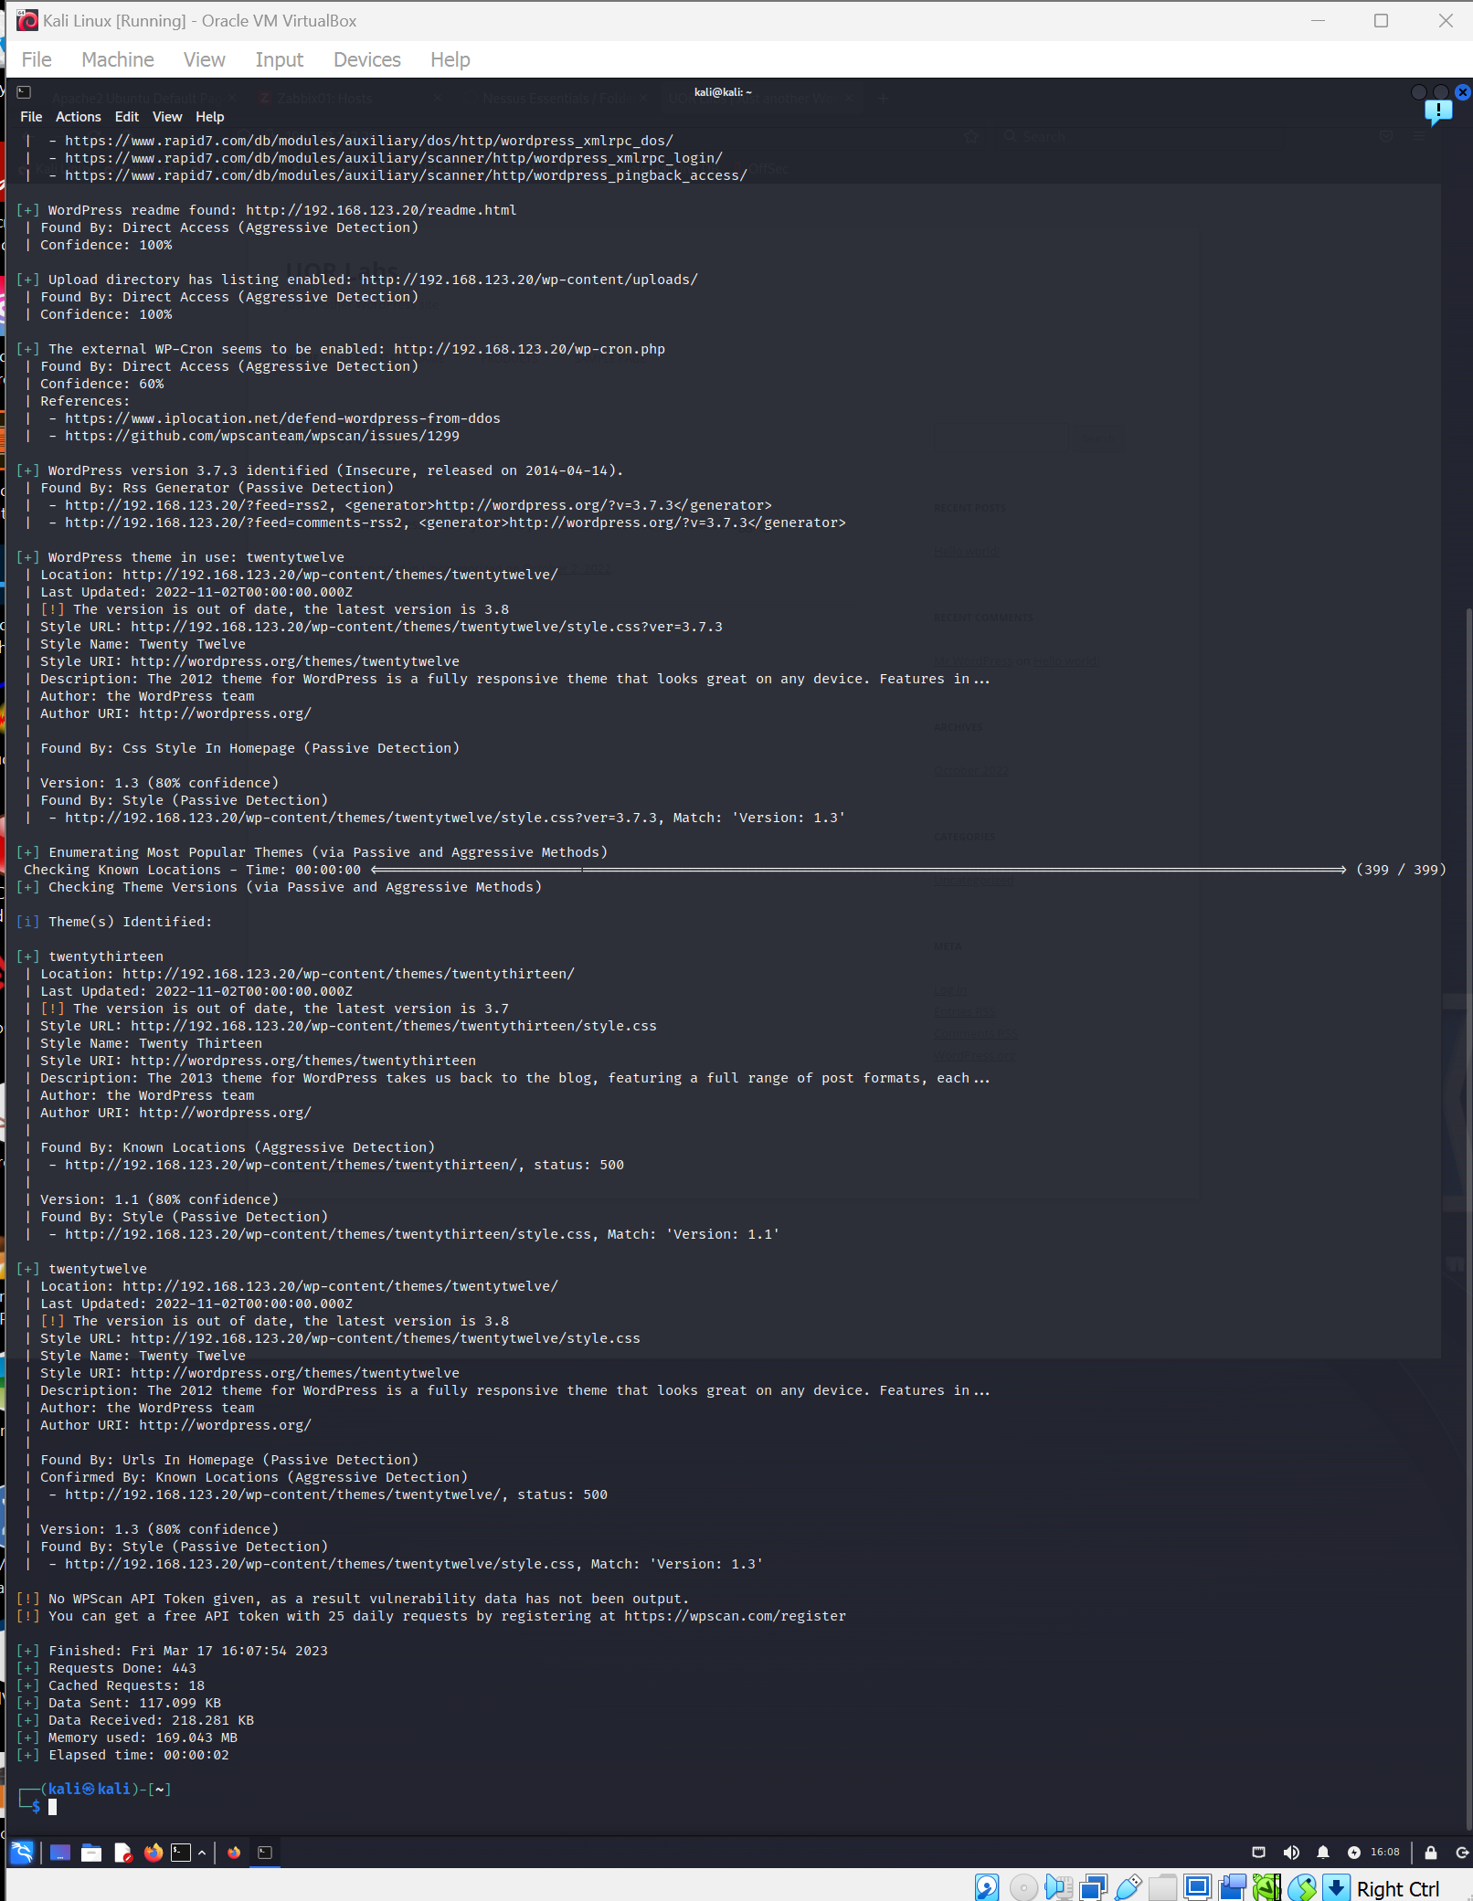

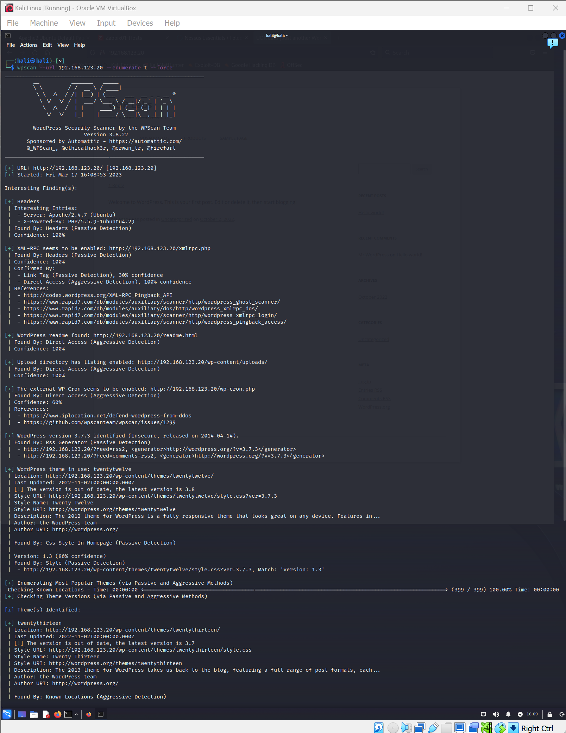

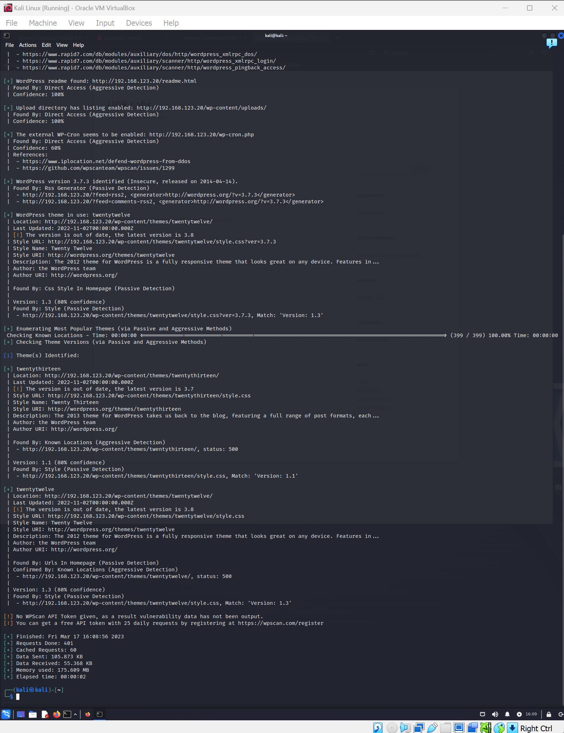

**6:** To scan WordPress for **vulnerable themes** (only), use the **enumerate** value in conjunction with the **vt** option. Type:

wpscan --url 192.168.123.xx --enumerate vt

**REPLACE THIS LINE WITH A CAPTURE OF YOUR SCREENSHOT(S) HERE!**

**Capture the command that was issued and the relevant section from the output that relates to the command.**

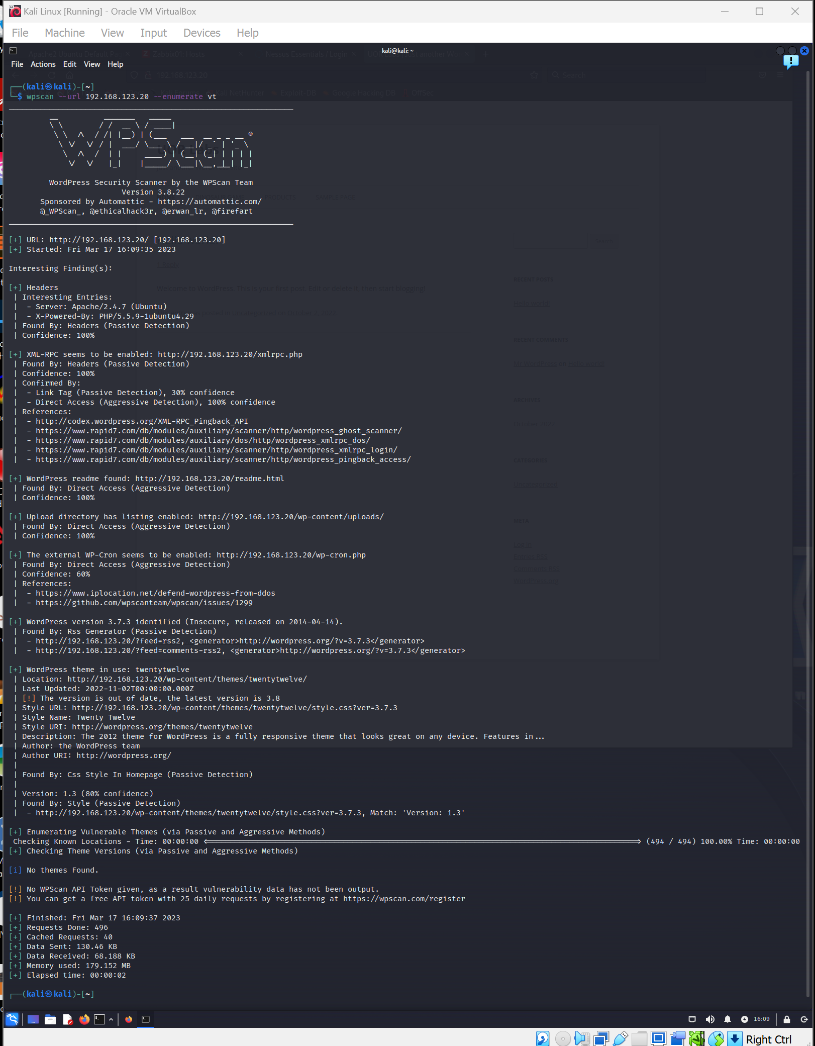

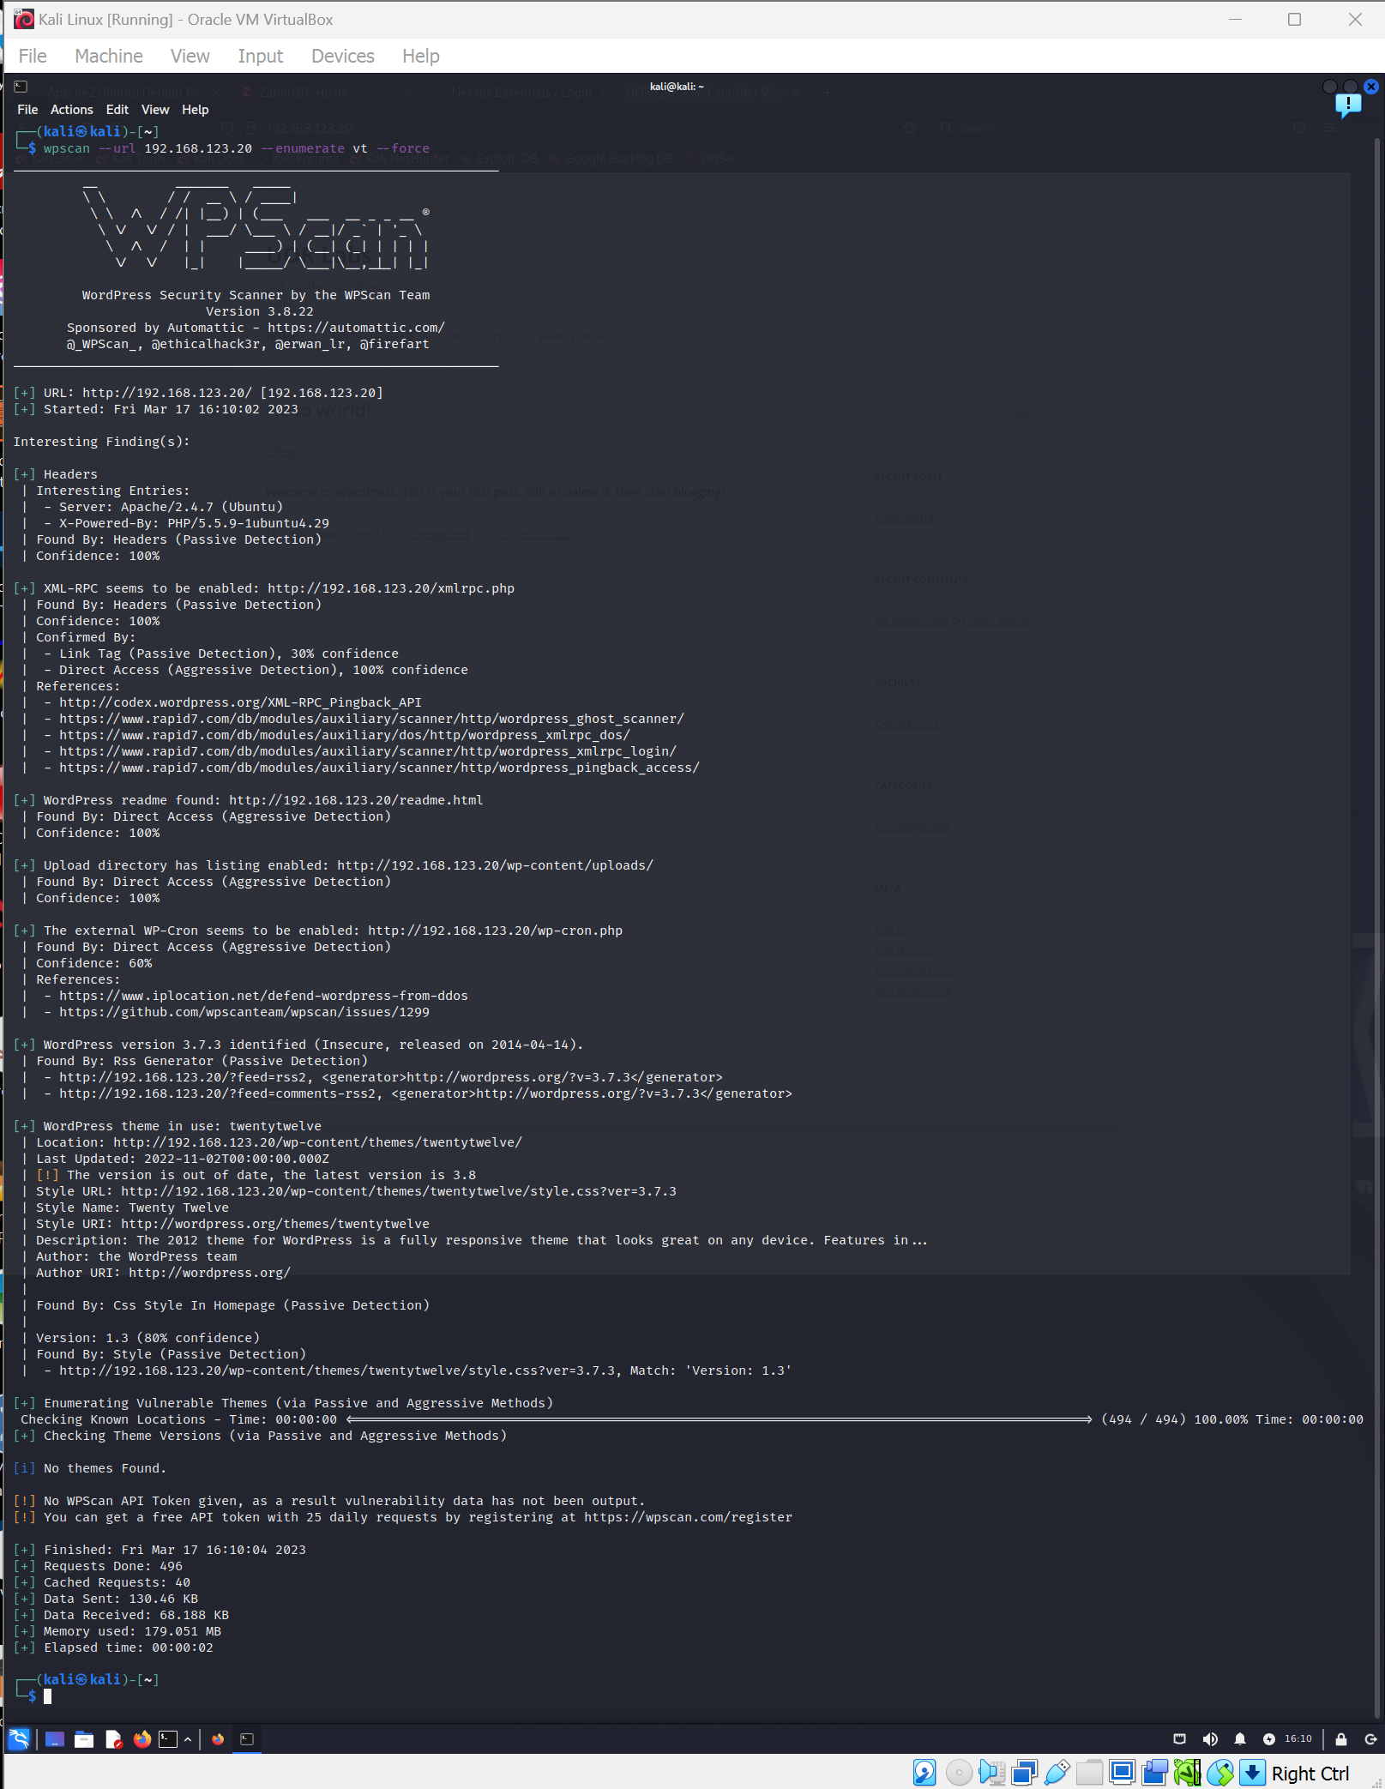

**7:** To scan WordPress for **all themes**, use the **enumerate** value in conjunction with the **at** option. Type:

wpscan --url 192.168.123.xx --enumerate at

**REPLACE THIS LINE WITH A CAPTURE OF YOUR SCREENSHOT(S) HERE!**

**Capture the command that was issued and the relevant section from the output that relates to the command.**

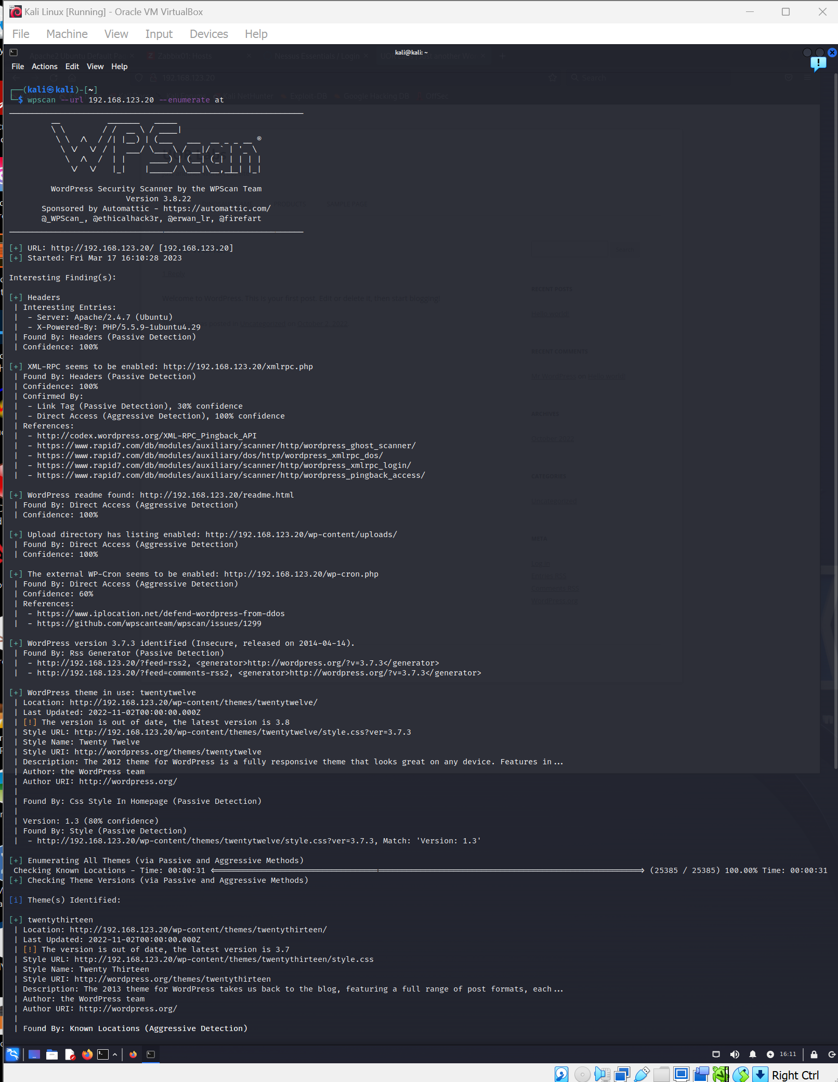

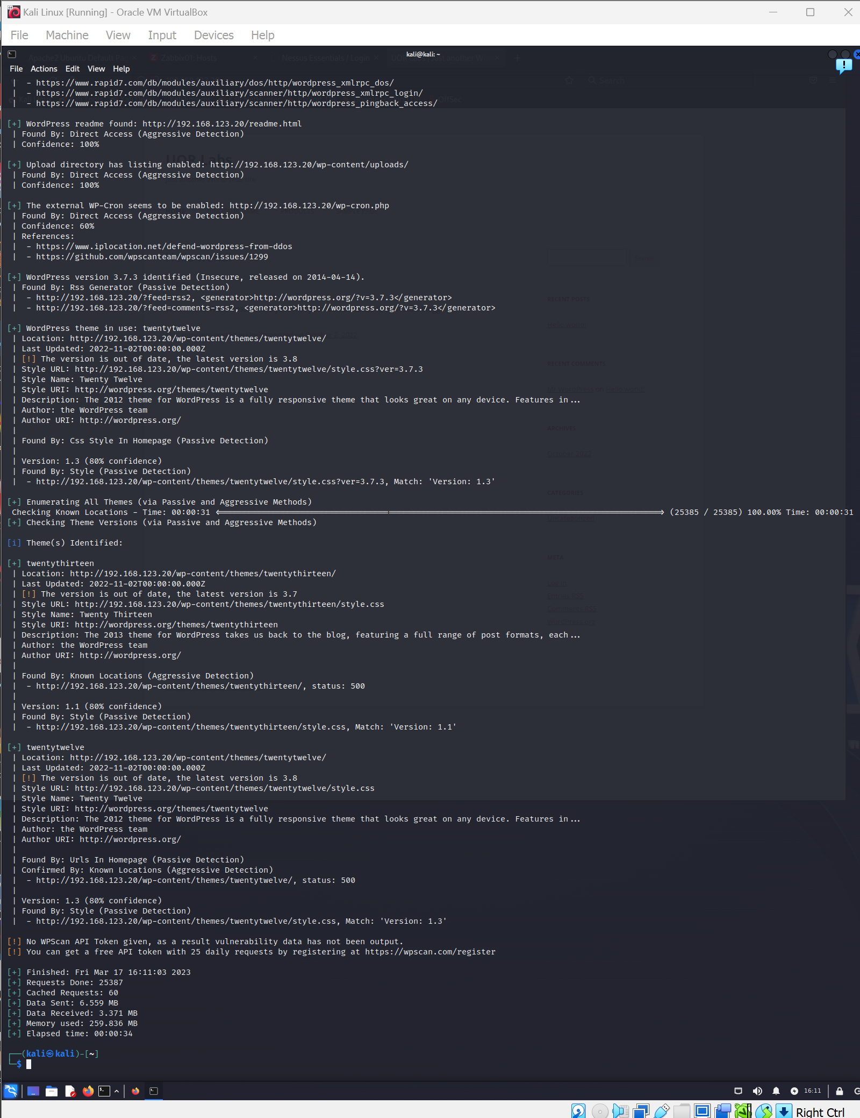

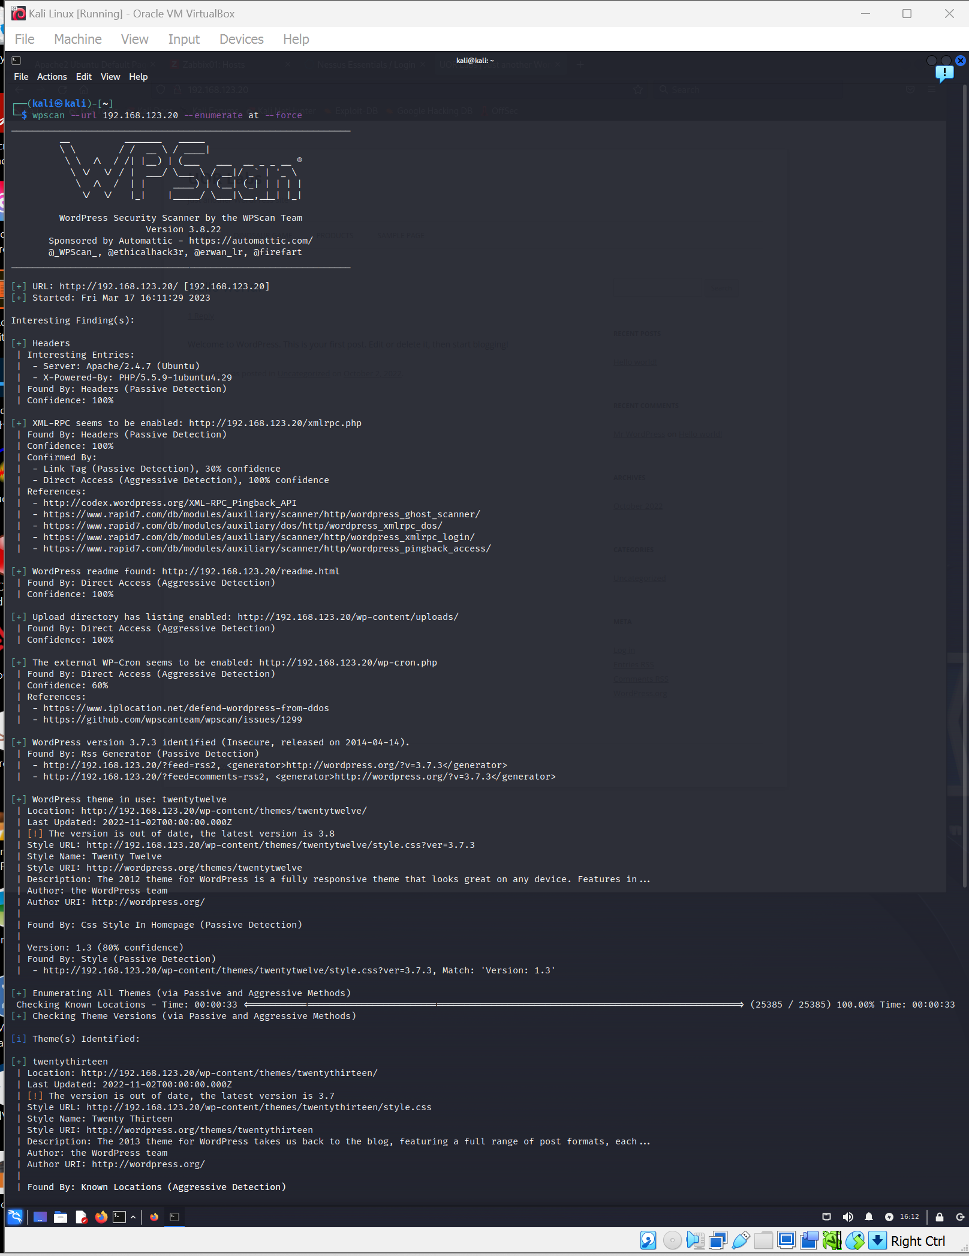

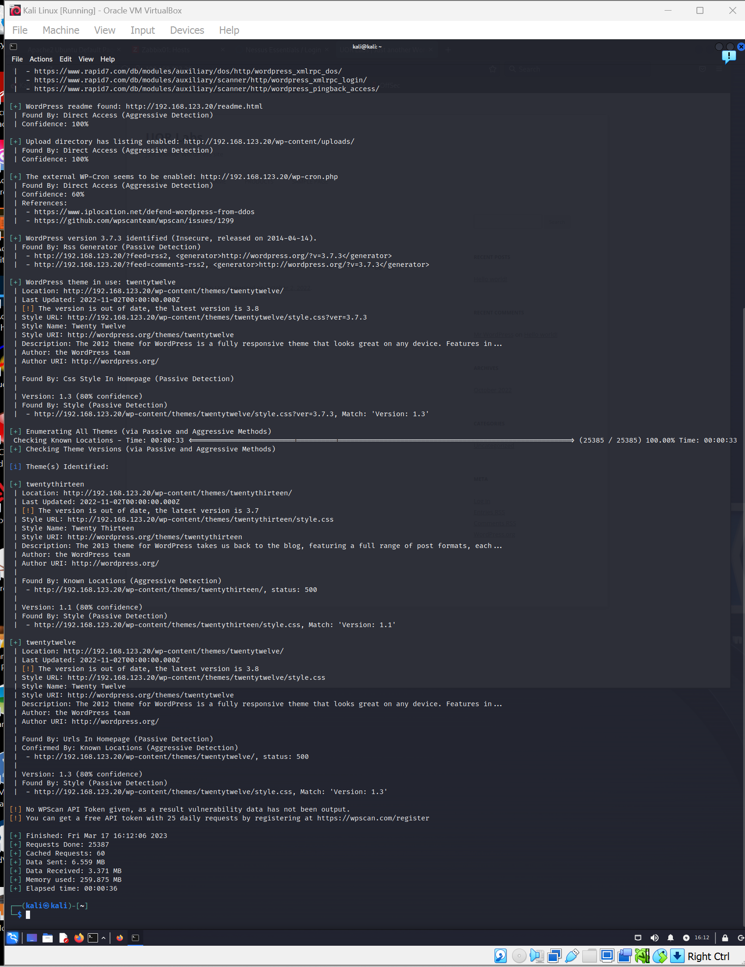

**8:** To scan for WordPress **usernames**, use the **enumerate** value in conjunction with the **u** option. Type:

wpscan --url 192.168.123.xx --enumerate u

Your result should be similar to the image below:

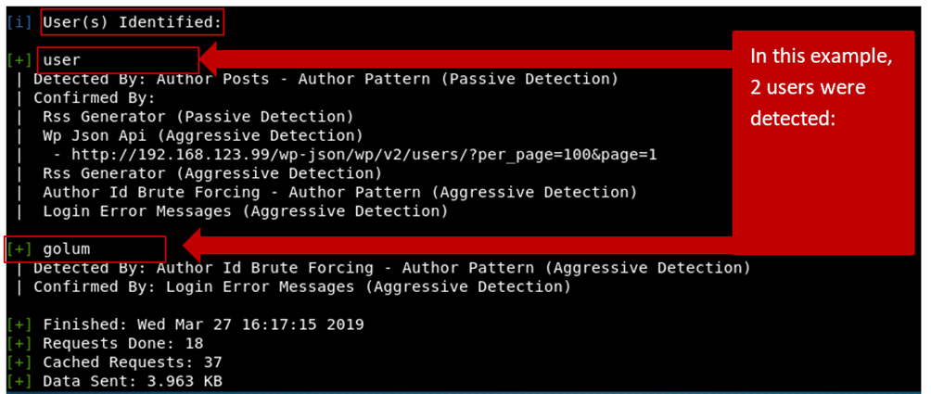

**Review the information from your scan carefully and capture a screenshot of the result.**

**Note**: All of the **enumerate** options described above, can be combined as required in a single command by separating them with a space.

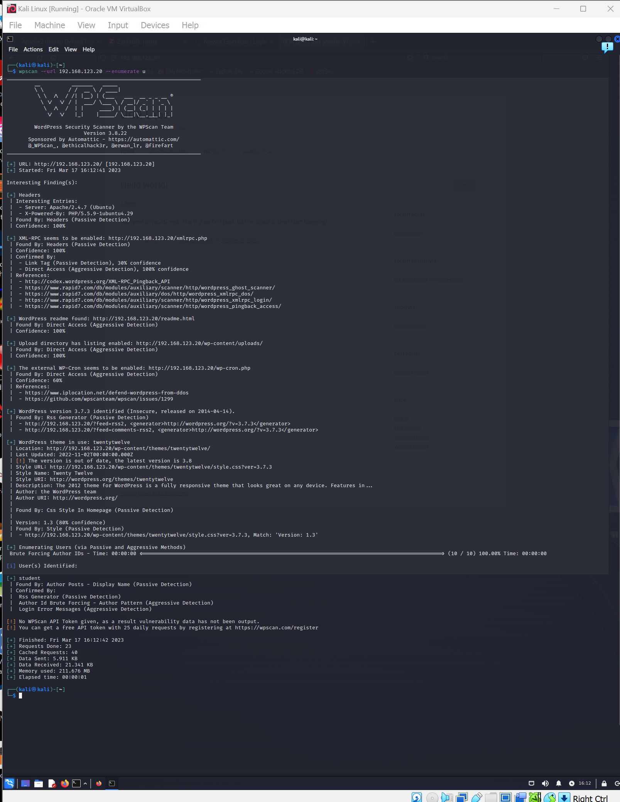

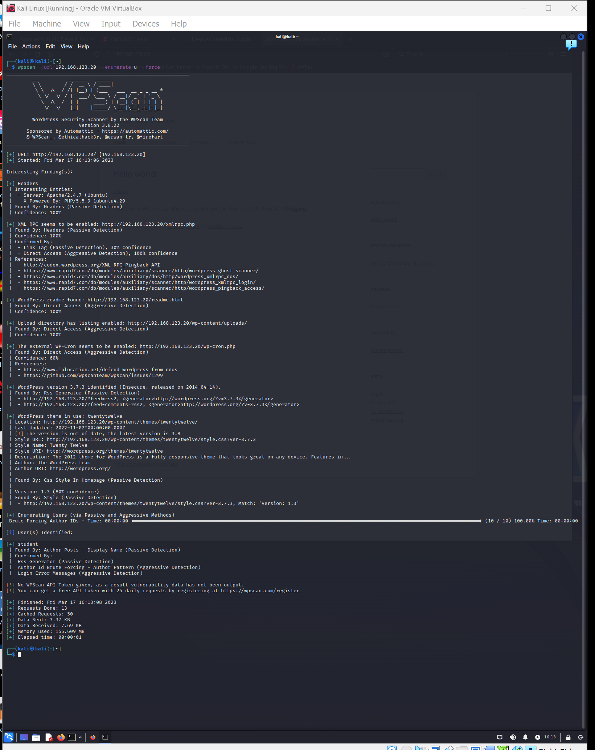

**Requirement B: A Brute Force Password Attack with WPScan**

Complete all of the following activities for wordpress. NOTE: Substitute xx for the value of your own WordPress virtual machine.

**Getting Started**

1. From your kali workstation, download a password attack dictionary.
   * You can download a file of approximately [10 million passwords here](https://gitlab.com/kalilinux/packages/seclists/-/raw/kali/master/Passwords/Common-Credentials/10-million-password-list-top-1000000.txt?inline=false)!
   * Save/rename the file as passwords.txt
   * Make a note of where the file has been downloaded to.

To brute force a password for a given user, type:

wpscan --url 192.169.123.xx --passwords passwords.txt --usernames nameofuser

where nameofuser is a name that you enumerated during step **8:**

**REPLACE THIS LINE WITH A CAPTURE OF YOUR SCREENSHOT(S) HERE!**

**Capture the command that was issued and the relevant section from the output that relates to the command.**

**username = student**

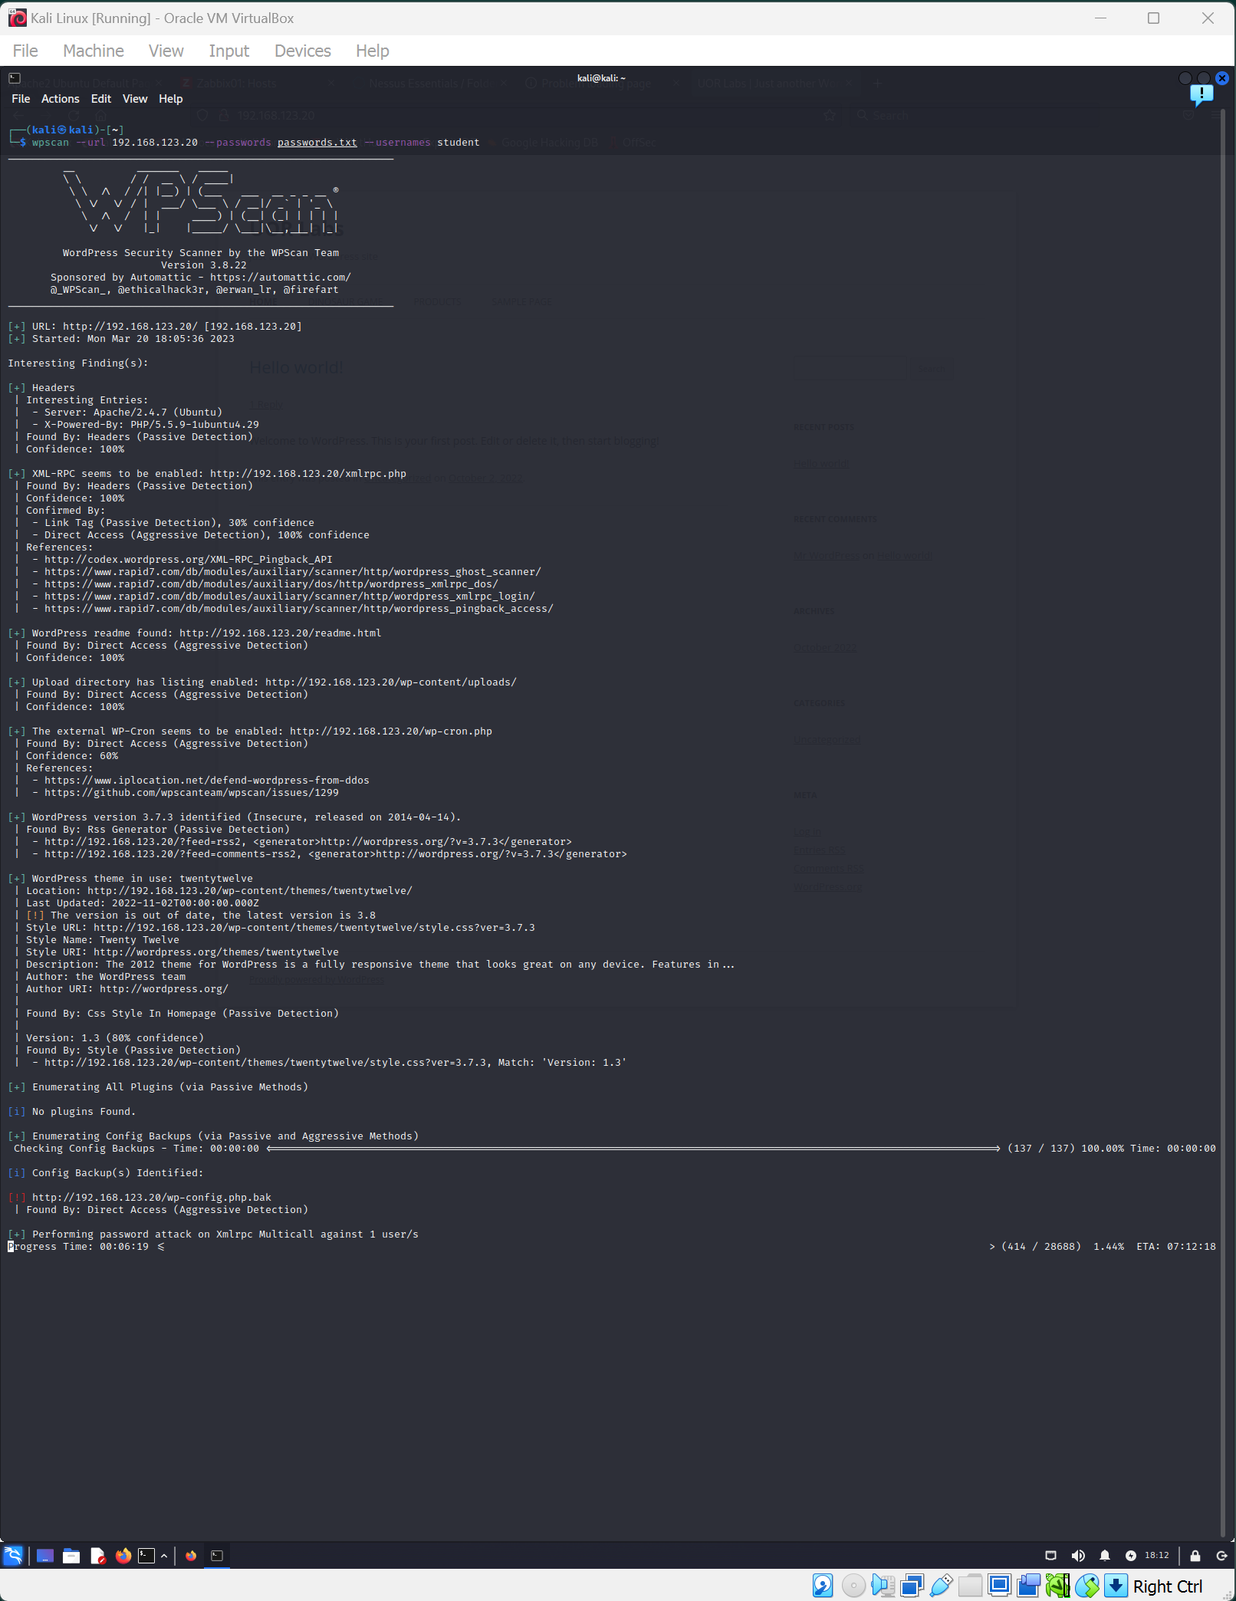

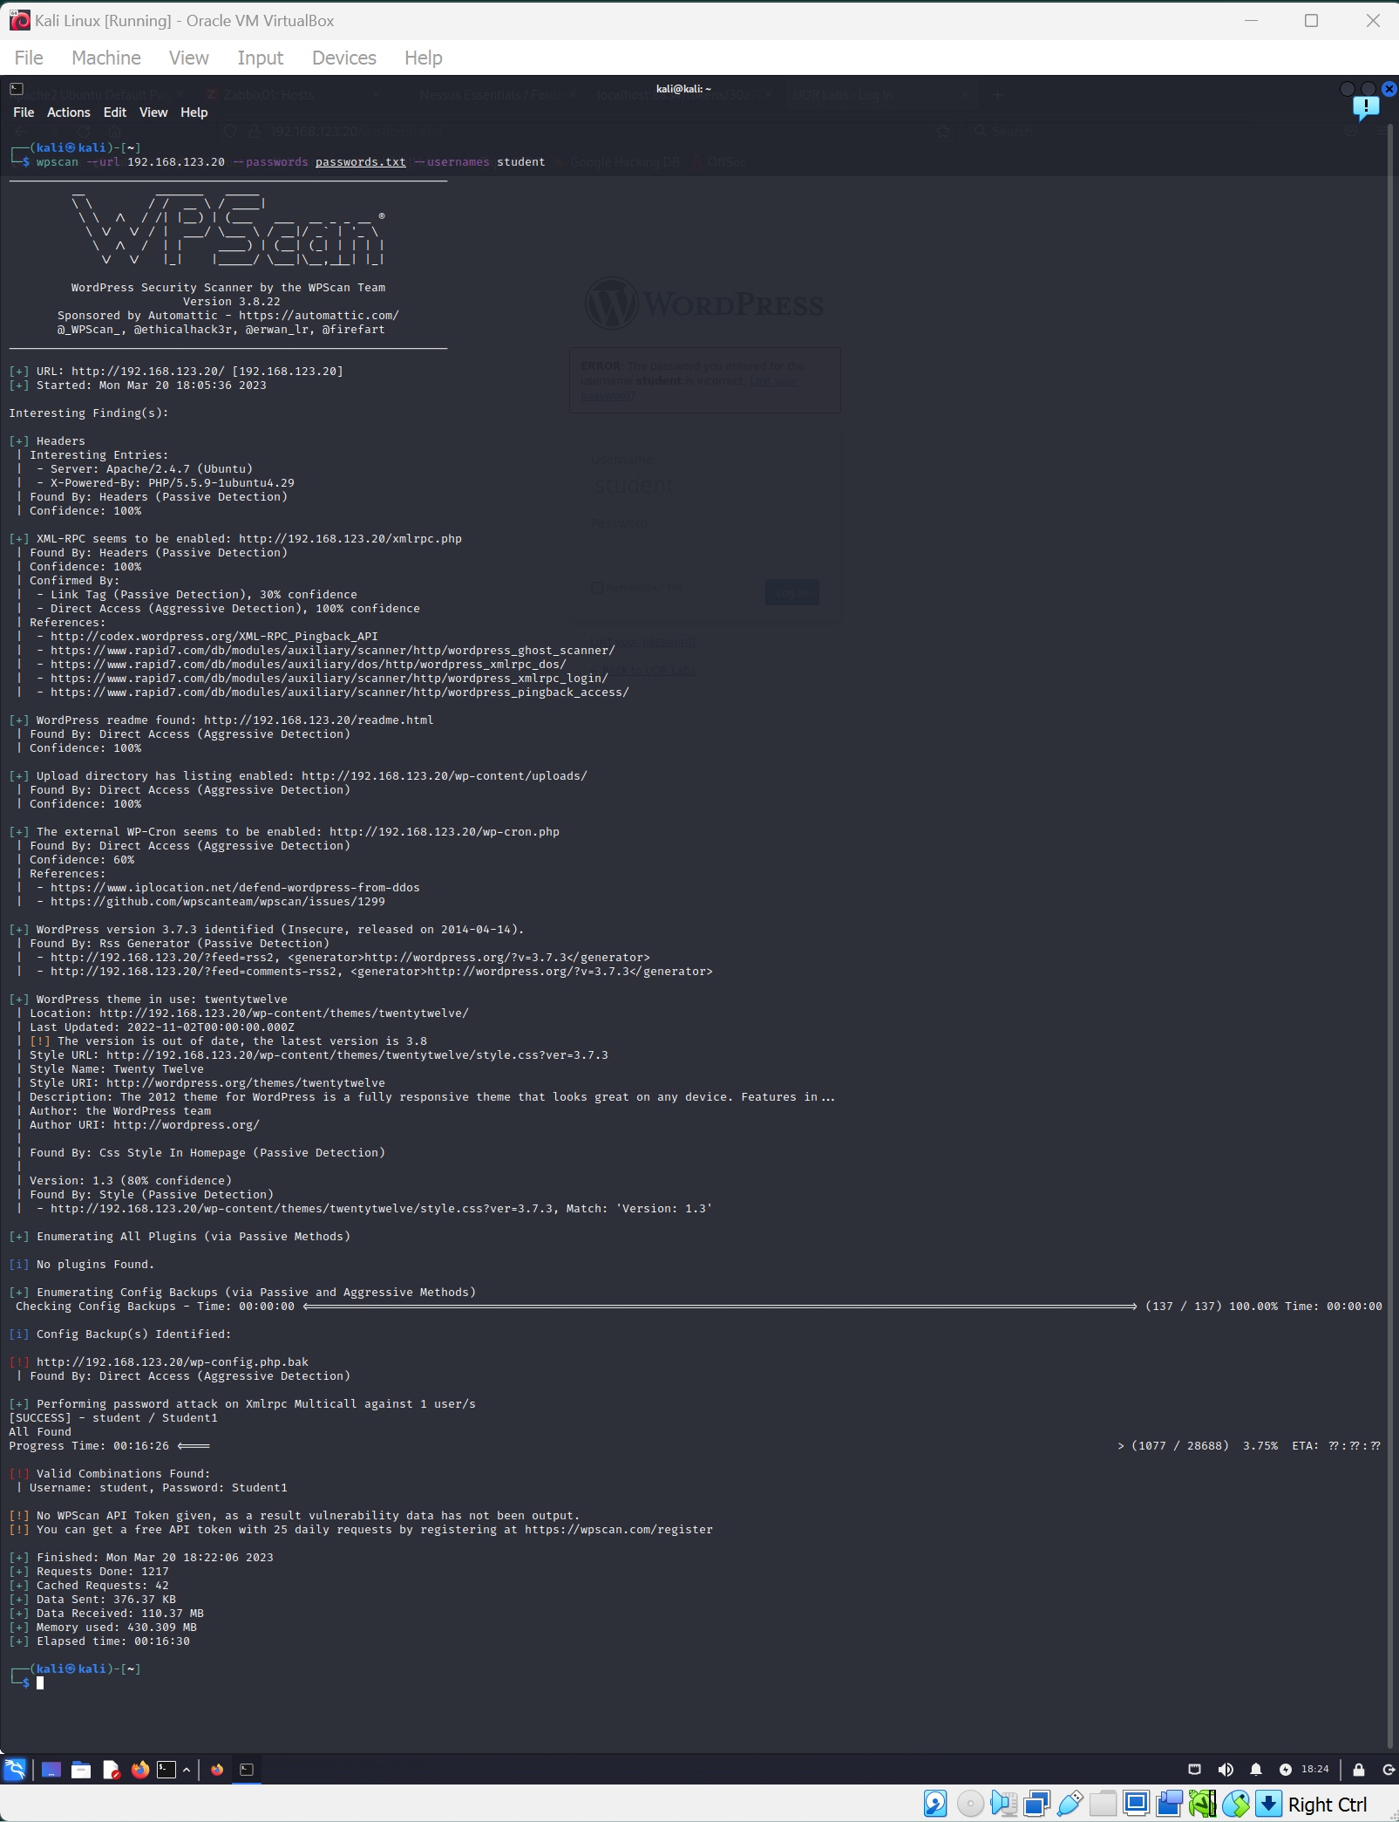

**Wow factor suggestions!**

It is feasible to pass this portfolio without completing any "wow factor". However, if you decide to take on this additional learning opportunity, the choice of what contribute is yours. Here is an example to consider:

* Explore and demonstrate additional and relevant WPScan commands that have not been covered in this portfolio.
* Explore and demonstrate other vulnerability scanning tools that can be used to evaluate WordPress Security.
* Add a WordPress Security plugin and evaluate security before and after adding the plugin.

End of Portfolio Lab :-)

Here I perform a scan to ALL VMs, trying to find more WP.

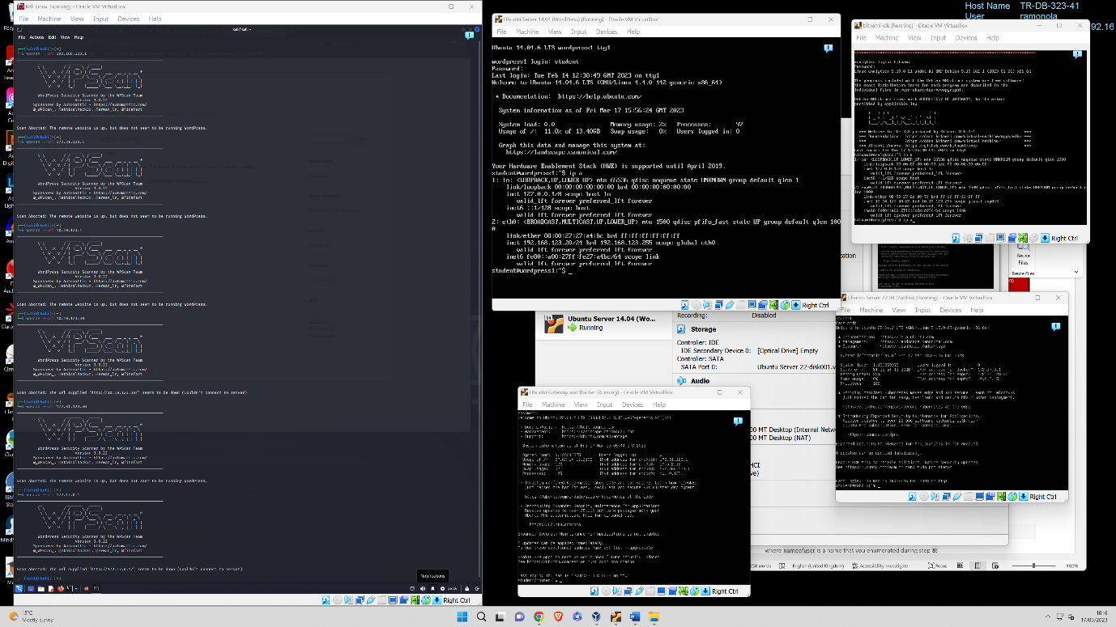

SOME EXTA COMMANDS

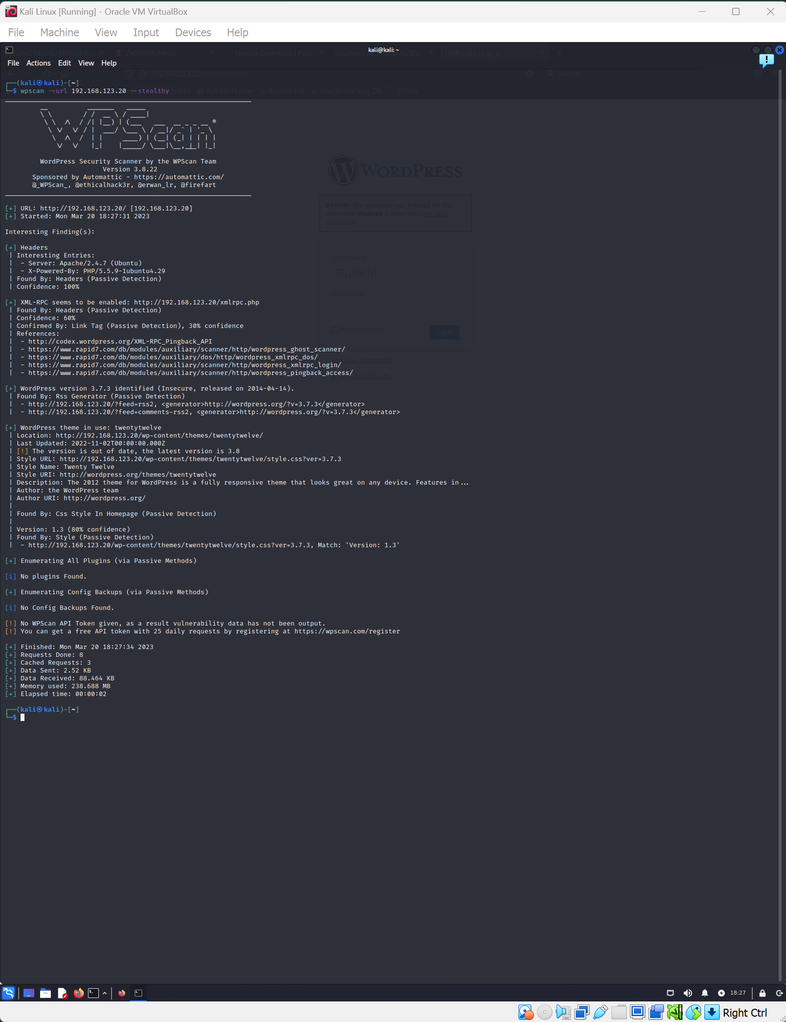

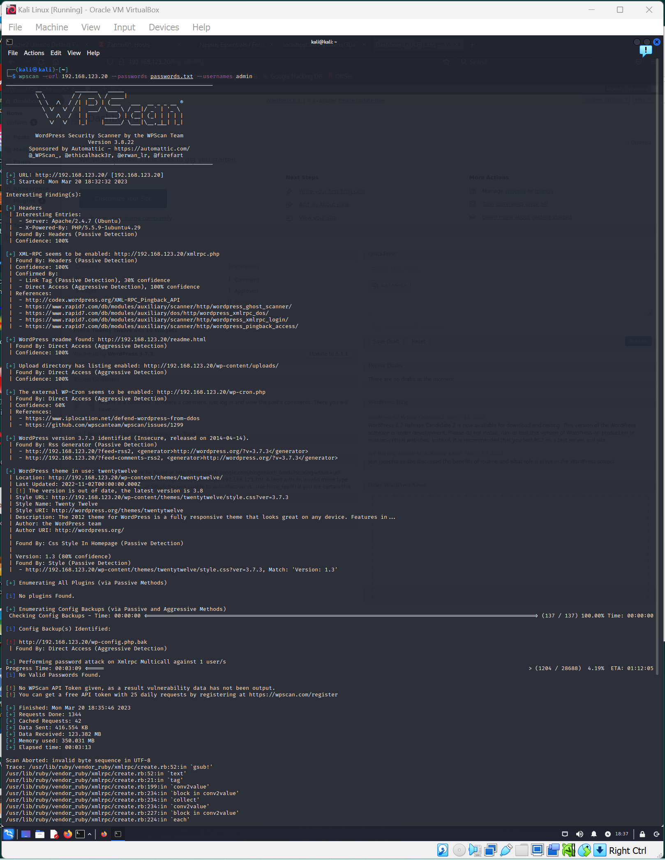

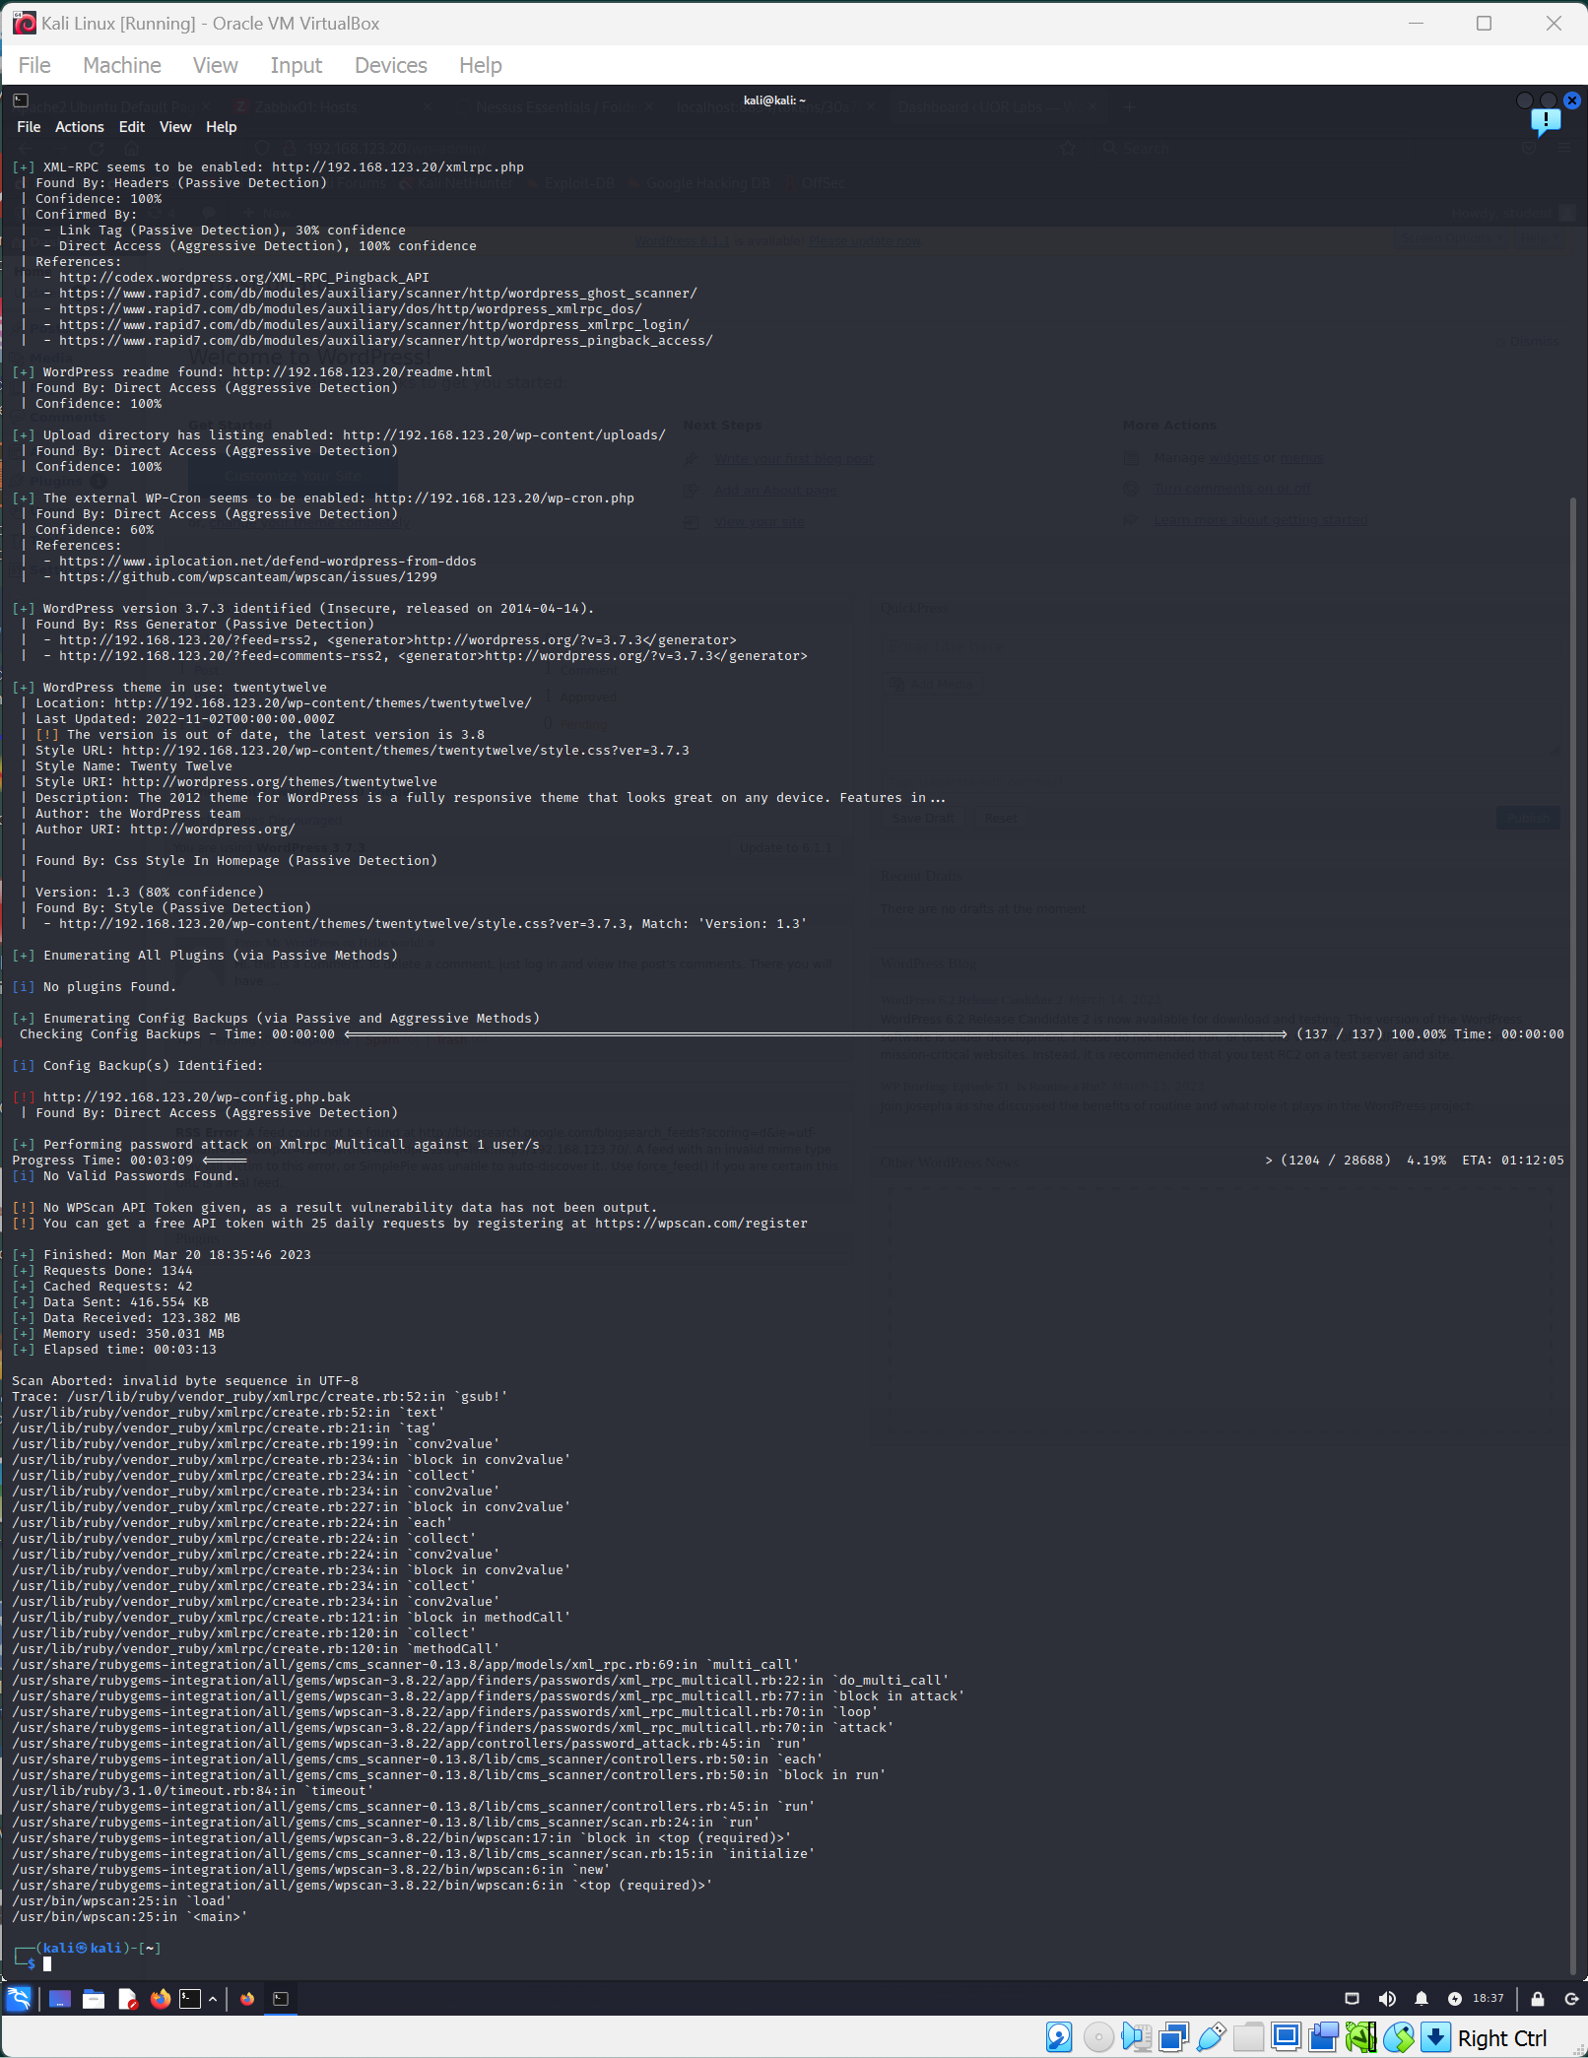

Here is visible my success login to WordPress website from kali Linux. WordPress server is in a different machine using a router (another VM).

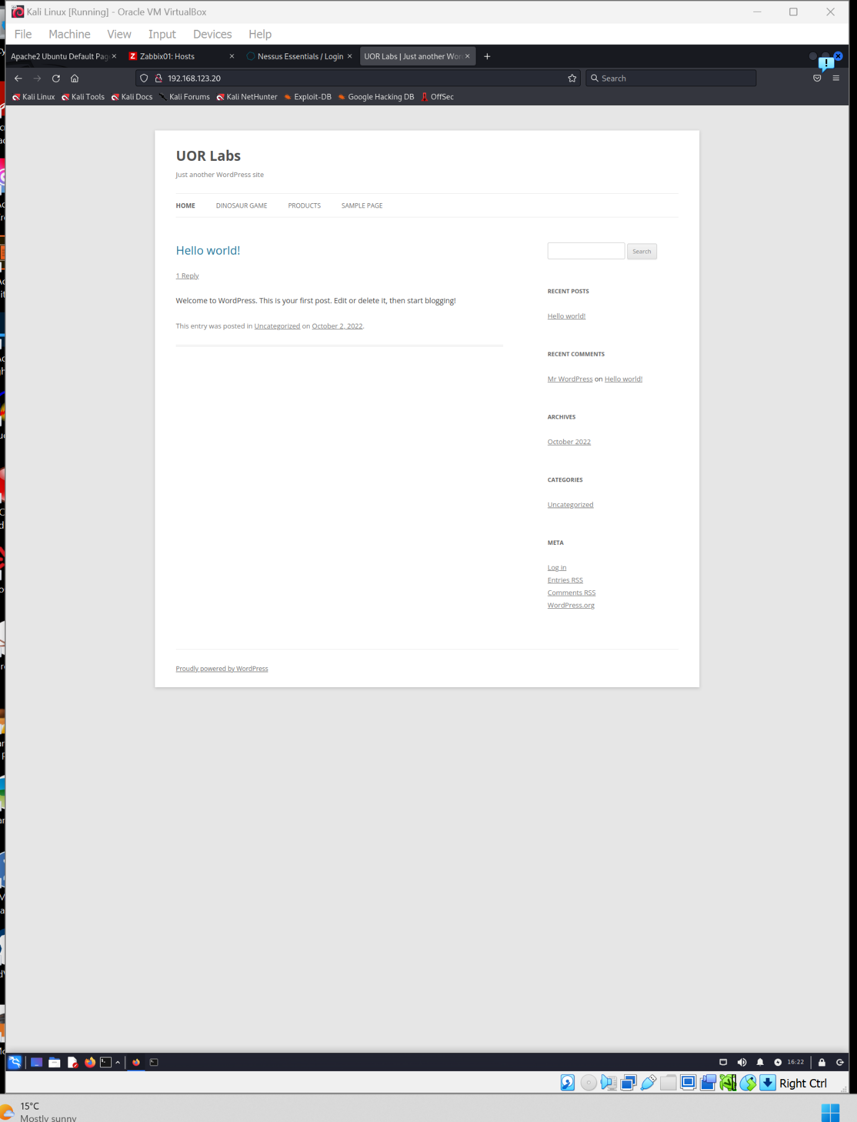

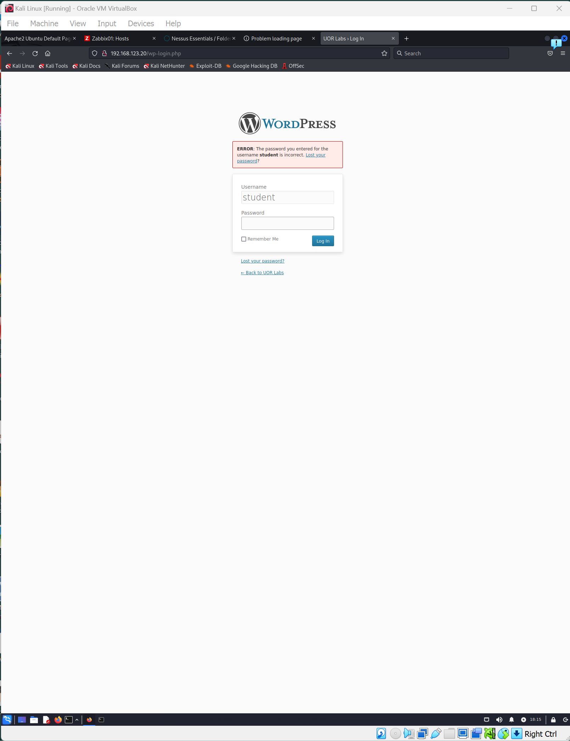

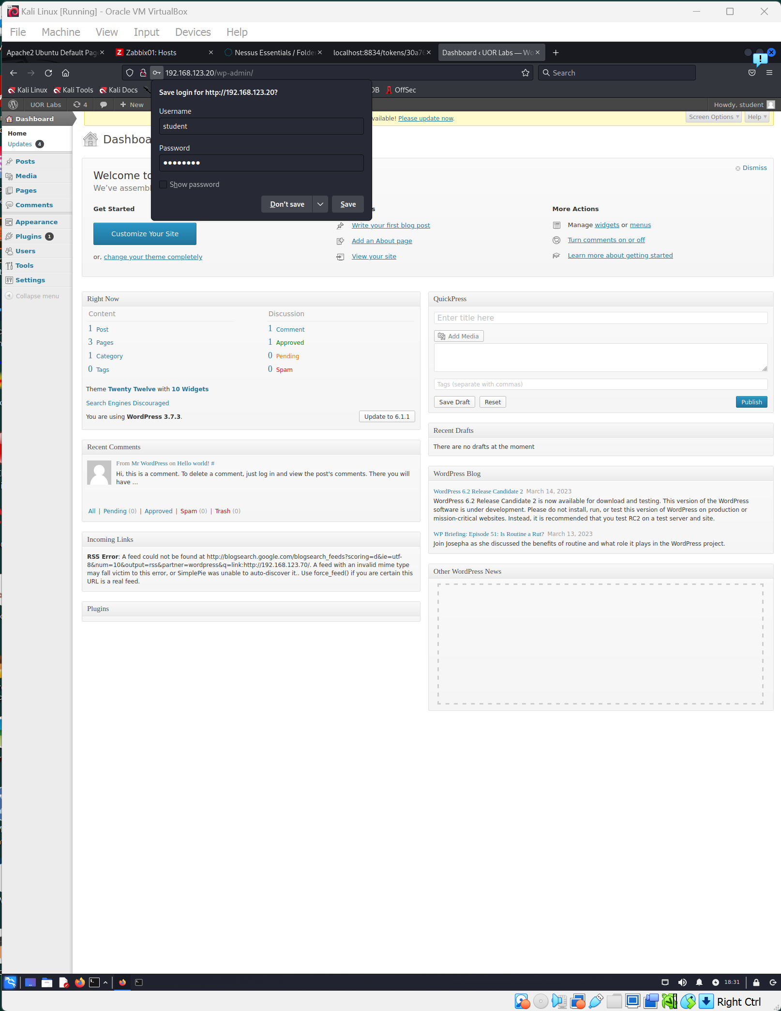

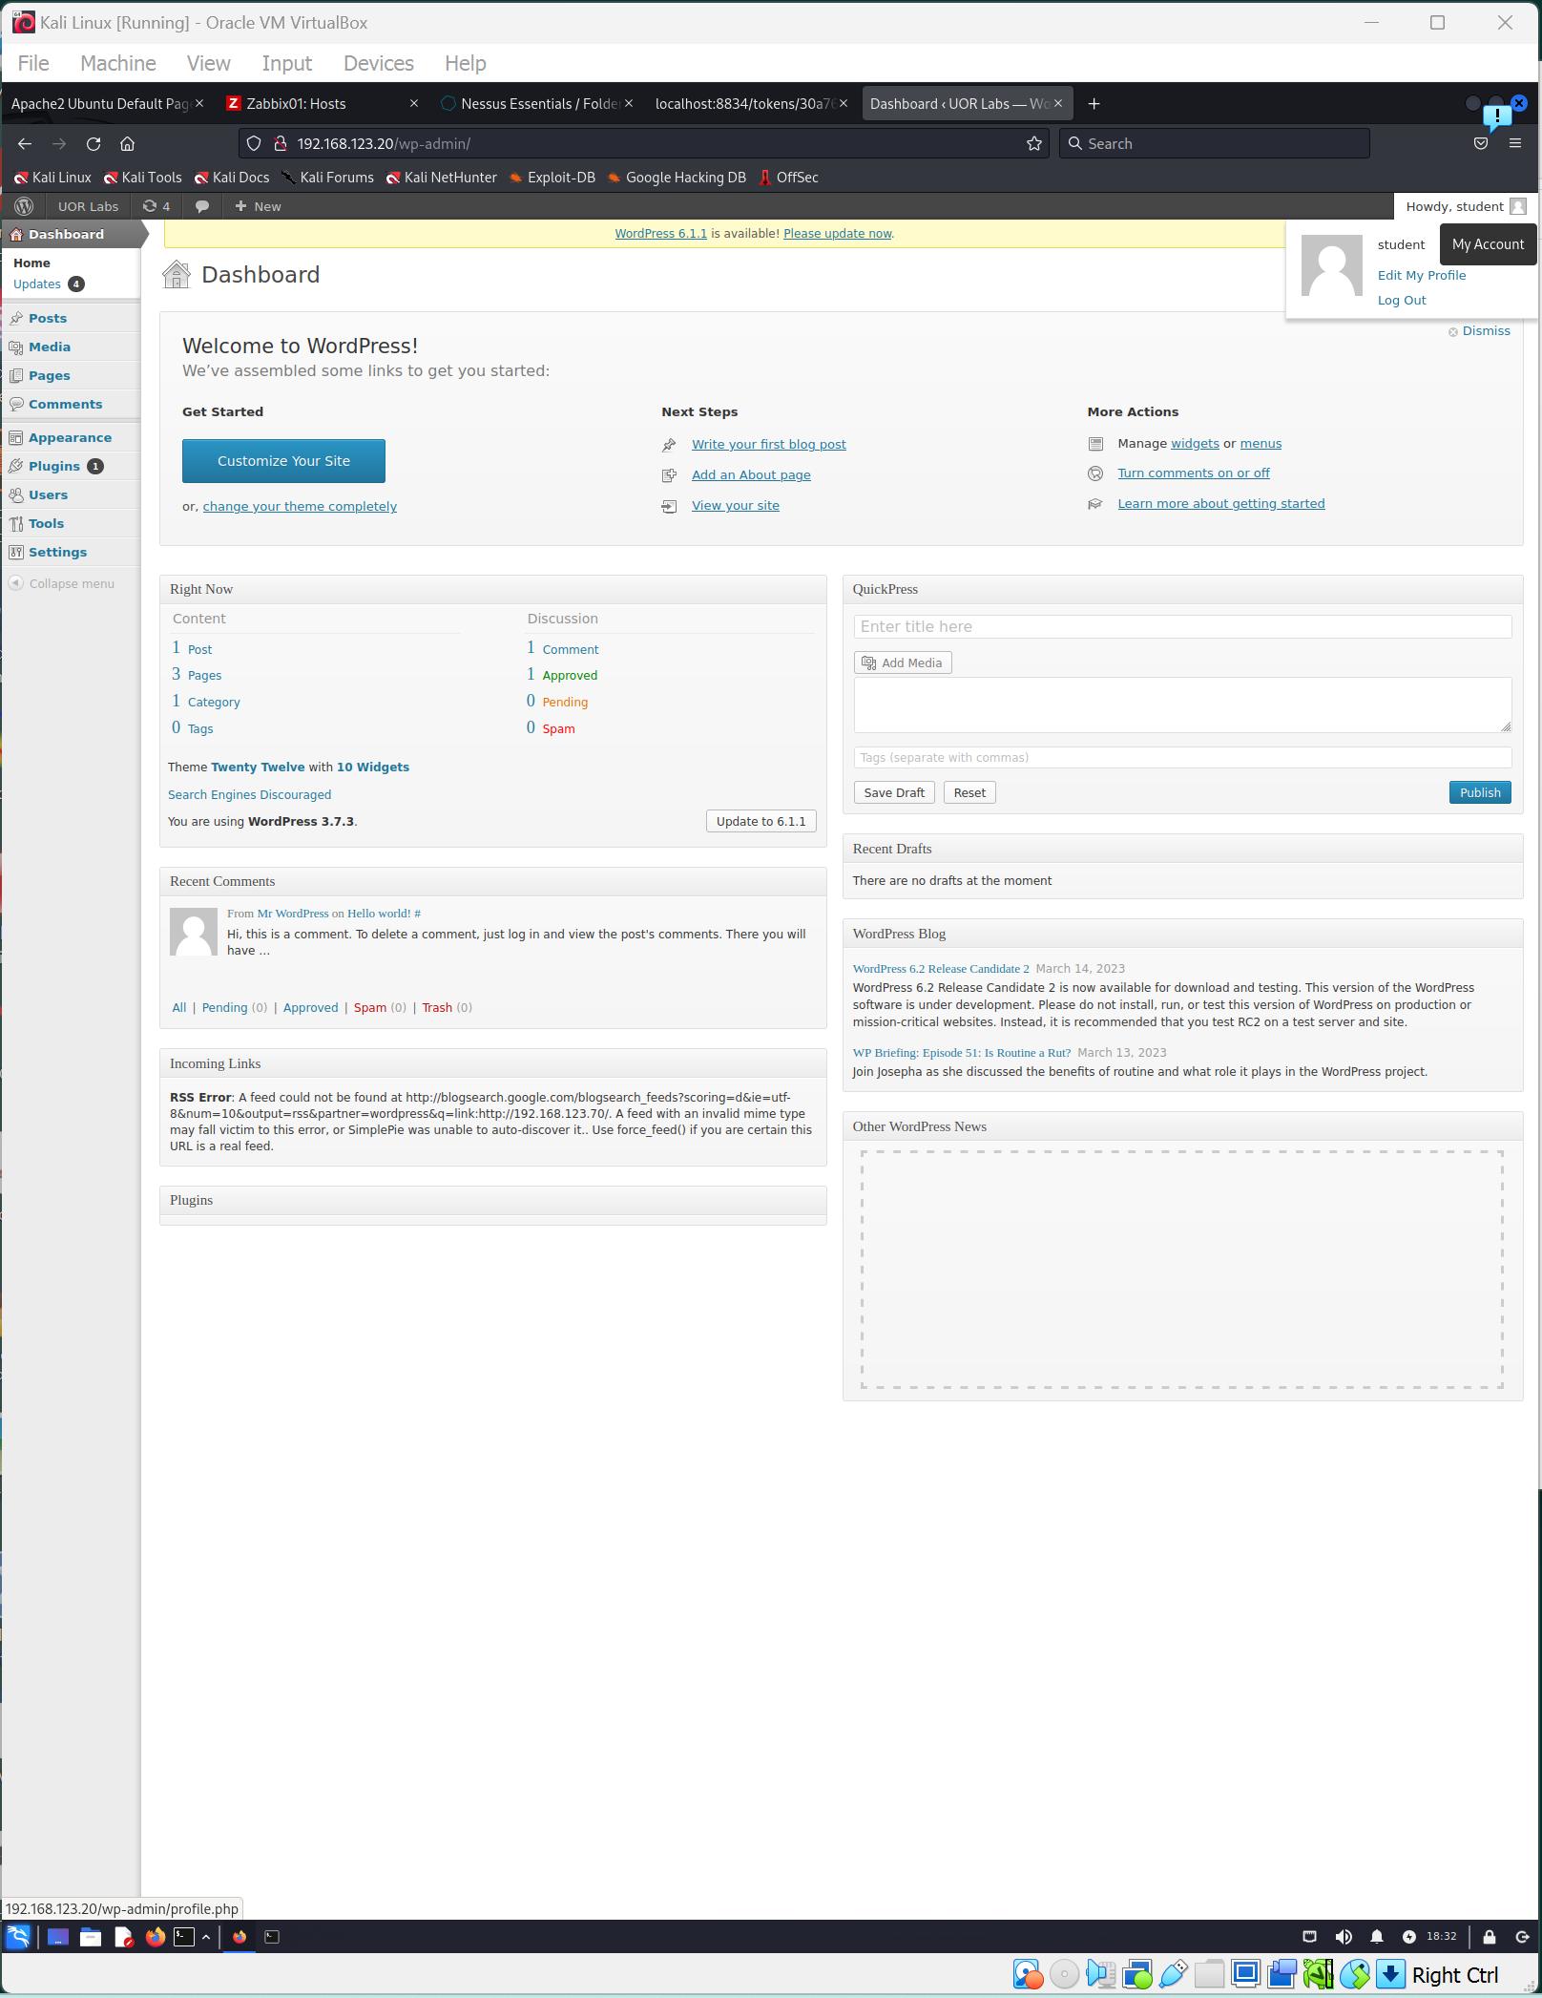

Useful links: <https://tools.kali.org/web-applications/wpscan> <https://www.hackmydevice.com/2018/05/how-to-hack-wordpress-site-using-wpscan.html>

**UPLOAD THIS COMPLETED DOCUMENT AS YOUR SUBMISSION TO MOODLE**